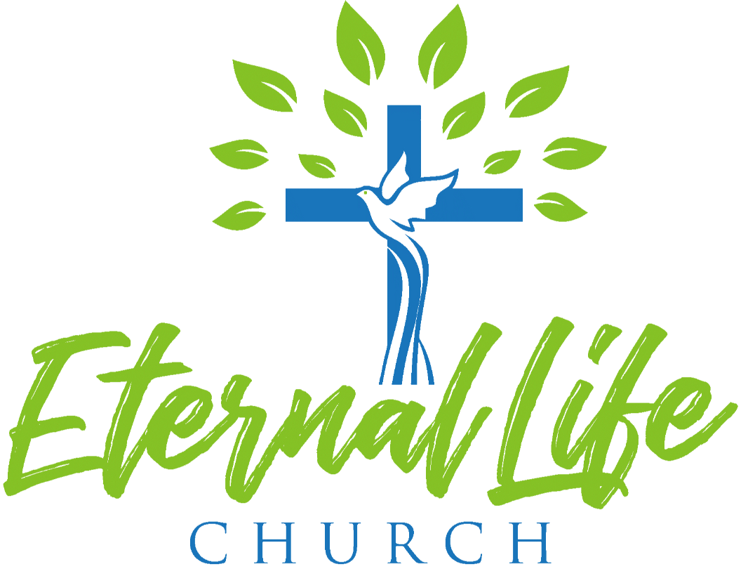

2022 Annual Report

Senior Pastor Annual Report

Calling of A New Pastor
As I reflect on 2022, it’s been a year of anticipating where and how God was leading my family and me. When I met with Pastor Christopher in 2021, I had no idea that that meeting would lead us together. God had ordained every step of our path for us to be here. Since being here, my family and I have received nothing but love and care from you, and we are grateful to be part of a church that loves God and display His generosity so well.

The transition of a senior pastor can be challenging. I want to take this time to acknowledge the stress, anxiety, or hurt this transition has caused for some of you. Changes are never easy, and it affects everyone, not just pastors. I pray for God’s peace and healing to be upon you. I want to assure you that I will do all I can to love you just as Christ loved the church.

I believe God has called my family and I here because we align with you to see the gospel reach all people here in Sacramento. As I look back on my journey, God has blessed my family and I to be part of different ethnic churches for this very reason. When I heard that Eternal Life Church desires to reach all people, I was filled with joy and excitement because this has been a prayer of mine for years: to see a Hmong church break out of their comfort, worship with all people, model, teach, train, and equip the next generations on what it means to love God, love people, and make disciples of all nationalities. In addition, Eternal Life is unique and special to be in a position to model for other Hmong churches what diversity could look like. I believe that God has brought me here to be part of this next season with Eternal Life. Exciting days are coming but not without challenges.

Hitting the Ground Running
In my four months, I’ve met with our governing board, both past and present, either individually or in groups. I’ve met with our congregations, coordinators, and church plant team, have attended small group events, mens events, and have visited families for prayer. I have weekly staff and 1:1 meetings with Kongchinh and Blong. I’ve started a newsletter to encourage our church and to share my family adventures. I’ve created a roadmap to help leaders focus on what we will do throughout the year.

Looking Forward
- To build a deeper relationship with my governing board, coordinators, and my congregation.
- To partner with our nearby churches, city council, schools, and non-profit organizations.
- To build relationships with pastors in Sacramento.
- To see our church make disciples that make disciples that make disciples.
- To grow spiritually and more profound with our relationship with Jesus.

Youth/Single Adults Pastor Annual Report
Coordinators: David & May Yang
Leadership team: Skyler Vue, Landon Yang, Evelyne Xiong, & Yvonne Yang

Theme: Be Brave
Bible Passage: Joshua 3 “Crossing the Jordan”

For the year of 2022, our theme for our you was to be brave. This concept of being brave embodies the ability to continue to move forward in the face of fears and trials. When we think about our faith, we understand that it comes with a lot of challenges. To some believers, these challenges are enough to stop them in their tracks, and because of this our objective this year was to build up our young people in their faith, that even in the face of fears and trials, they would still be able to continue forward in their pursuit of the Lord.

2022 Major events: Being that Hlub camp did not fall on this year, one of our objectives was to provide a summer youth camp where the youth would be able to get away for a couple of days and grow in their relationships with the Lord as well as one another. This year’s fundraising efforts went towards making this possible.

- Fundraisers
    - Yard workk/cleaning: One of the ways the youth raised funds this year was to provide cleaning services in exchange for donations. This year, the youth took on a couple of tasks in terms of cleaning yeards, assisting in installing a drip system, and simple yard maintenance.
    - Service: Many times throughout the year, the youth’s services are requested to assist in larger events. This year, the youth was able to assist in events within the church as well as a wedding outside of the church, and in doing so received donations for their work.

- Youth Camp: This year, with the funds acquired from our fundrasiers and the help of our parents, we were able to hold a youth camp over the summer for our youth. The camp that we stayed at was Golden Valley Camp in Volcano, California, about an hour and a half drive east of our church.
At the camp, the youth took part in games and team building activities to strengthen their relationship with one another. Morning and evening worship and devotion times were held and lead by pastor, our coordinators: David & May, and chaperones: Peter & Chue Lo.
- Lock-in: Towards the end of the year, the youth usually would usher in the new year with a church lock-in event where the youth would stay at church all night on the eve of the new year. This year, because the new year fell on a Sunday, we decided to have the lock-in event a day earlier.
At the lock-in even this year, we started the night out with worship by pastor, and a devotion by our very own youth leader Evelyne Xiong, followed by dinner. After dinner, the youth took part in our white elephant Chritmas gift exchange, and followed it up with games prepared ahead of time by the youth leadership team. After the games and activities, the youth would then have free time to fellowship or sleep if they wanted to. Breakfast was provided in the morning while our youth waited for their rides back home.

- Fellowship: Our youth ministry holds two different types of fellowship throughout the month: 1. Our weekly fellowship that happens every Wednesday evening from 6-8pm, and 2. Our end of the month fellowship that happens on the last Friday of every month.
Wednesday Night Fellwoship: Our fellowship on Wednesday’s serve as a means for the youth to simply be in communication with one another. Sometimes Sunday go by so fast and we don’t get to actually talk and pray with one another. Our Wednesday night fellowship provides a place where the youth can be dive into the word, take part of activities, and pray for one another.
End of the month fellowship: Our fellowship on the last Friday of the month aims to build relationships through games and activities. For this year, we wanted the youth to fellowship with one another both in and outside of church settings. We decided that we would alternate, one month we would fellowship at church, and the other month we would take the youth out (i.e. roller skating, etc.)

Missions Ministry

Committee Members:
Jeff Yang, Julie Xiong, Tony and May Yang, Stephen Vang, Gance Ly, Maria Heu, Blong and Kao Zong Thao

Vision Of Ministry:
To provide information to our members on God's greatest commission to us in sharing the gospel. As a CMA church, we strive to understand ministries overseas and locally so we are aware of the resources needed for the Great Commission. In order to do this, we bring missionaries to share their experiences.
We are working towards doing more outreach locally to share the gospel and find the needs of our own community.

Theme:
2022-2023 Missions Theme: Be Present

Summary of Yearly Activities/Number of Attendees:

Events/Number of Attendees | Summary of Event
Date: Saturday, November 19, 2022 (10 am -12 pm)  Number of Attendees:  - Volunteers: 25  - Guests: 250 | Thanksgiving Giveaway  Summary of event:  Prior to the event, we took two days to hand out over 2,000 flyers to local apartment complexes north and south of ELC (i.e. Summerset Apartments).  On the day of the event, we had two areas set up. First, we set up donated items in the south parking area. These were items donated by our church members. It included clothing, household decor, toys, and small appliances. Each person who came by was encouraged to take some of the donated items home. There was also a table set up near the north multipurpose door to giveaway the turkeys.  We gave away all 200 turkeys that day and 90% of the donated items.
Date: December 3-4, 2022  Number of Attendees:  - Saturday: 75 (Morning event for all)  - Sunday: 169 (Hmong and English Service) | Mission Conference - Theme: Be Present  Summary of event:  Our guest speaker for this event was Aaron & Rhoda Steinert. They are missionaries to Berlin, working specifically with the Muslim population.  During the two-day event, the Steinerts shared personal stories and testimonies. They encouraged ELC to serve God on mission locally and to think globally. At the end of the event, we encouraged our congregation to make a pledge toward the Great Commission Fund.
Date: April 3, 2022  Number of Attendees: 150 (English Service Only) | Easter/Passover Seder  We invited Chaplain Jacob Cohen and his wife back to ELC to go over the biblical and hidden elements in preparation leading to the Passover. He had a table display set as a Jewish home would in celebrating the Passover. The elements would come to represent the significance and covenant of the Last Supper.
Date: February 12-13, 2022  Number of Attendees:  - Saturday: 50 (Youth and Single Adult Night)  - Sunday: 150 (English Service only) | Mini Missions Conference with Brett Bower.  Emphasis on youth development.  Missions Message: All of Jesus for All the World  Summary of event:  Our honored guest, Brett Bower, a missionary on home assignment was here to talk to us, specifically the youth. This was a two day event where Brett shared his experiences overseas, the culture and work he is doing in France with his wife. They served in Kosovo for 4 years then transitioned to Paris, France in 2010 where still today, there is only 1% of evangelical Christians. Brett and his wife serve as directors of their cultural outreach group to mentor and develop leaders.

Overall areas of success:
This year we were able to have three conferences (one local and two with ministries overseas). Most years, ELC has only done one Mission’s Conference.
Although not part of this team, six ELC members were also able to share overseas ministries that traveled to Bangkok, Thailand to learn about the culture and ministries with Envision Bangkok. We held a service in Hmong and English Service to share what we learned.

Overall areas of needing improvement:
We would like to see more engagement from members when we do community work locally. We are a blessed and giving church. Members are very giving, but would like to see the Board’s support or give us the vision on how we can better serve our MLK community as a whole church.

Men’s Ministry

Men’s Ministry Annual Report 2022
Committee Members:
Alex Vang, Nou Vang, Hang Xiong, and Ger Vang
Vision Of Ministry:
Working as the body of Christ to faithfully serve and build up our fellow brothers and neighbors at ELC by reciprocating the love He has given us and sharpening each other through scripture, testimonies, and devotions as we’ve gathered for our events throughout the year.
Theme:
Be Christ Like – Inspire, encourage, and support ELC men and neighbors for spiritual growth and help each other to understand what it means to be more Christ like, as He sacrificially served us all with mercy, grace, and love.
Summary of Yearly Activities/Number of Attendees:
Events/Number of Attendees | Summary of Event
Date: February 19, 2022  Number of Attendees: Men Ministry – approximately 25 | Men’s Ministry Breakfast Event  ● Brotherhood breakfast & fellowship.  ● Praise & worship by AV team Peng, Jeremy, & Michael.  ● Devotional by Kou Khang & testimony by Seng Thao.  ● Prayer requests submitted to VaToua.

Date: March 12, 2022  Number of Attendees: Men Ministry – approximately 25 | Men’s Night  - Men’s fellowship, food and games.  - Brother Jerry “ Read, Hear and Keep and read into the Word of God.  - Praise & worship Devotional by Toua Vang (EG) and testimony by Xeng Her  - Communion with Jerry Lao
Date: April 9, 2022  Number of Attendees: Men, Women, & Youth Ministry – approximately 70+ | Men, Women, & Youth Recreational Day  ● All day picnic & recreation partnered with GG & Youth Ministry.  ● Praise & worship by Va Meng Thao  ● Volleyball, Flag football, and Fellowship  ● Provided lunch and drinks.
Date: June 18, 2022  Number of Attendees: Men, Youth, and some children – approximately 20  Date: July 23, 2022  Number of Attendees: Varied – approximately 200+ | Men’s Ministry Zipline at Quarry Park Adventure ● Picnic and event (food and drinks provided) ● Praise & worship  ● MM T-shirt giveaway, Fellowship and games  ELC 2022 Annual Picnic  ● BBQ and Fellowship  ● Praise & worship  ● Baptism  ● Volleyball Tournament  ● Children’s activities, games etc.
Date: August 27, 2022  Number of Attendees: Men Ministry – approximately | Men’s Ministry Summer BBQ  ● BBQ dinner & fellowship.  ● Praise & worship by Cheng Vue.  ● Game by Hang Xiong.  ● Testimony by Kyle Lee.  ● Scripture Teaching by Xf. Christopher Thao.
Date: October 21-23, 2022  Number of Attendees: Varied – approximately 43 | Men’s Ministry Camp Alta Retreat  ● I AM -Jesus, More Than Enough (theme)  ● Speakers Pastor Blong and Jerry Lao

● Praise & worship/ AV by Marco, Peng Her and Teng Her
● Devotion by Brown Moua
● Testimony by Ryan Kurk
● Campfire, fellowship and reflecting etc.
● Special Guest by Pastor Christain Vang
● Gift Bag with MM T-Shirt
Date: December 16, 2022  Number of Attendees: Men Ministry – approximately 32+  Date: July - December 2022  Number of Attendees: Men Ministry – approximately 6-12 | Men’s Ministry Christmas  ● Christmas dinner potluck and gift exchange. ● Praise & worship by Marco.  ● Devotional/testimony by Roberto Garcia, Tswv Bee (Yabee) Yang, & Xf. Blong Thao.  ● Blessing Prayer for NY by Xf. Christian Vang. ● Teaching: 7 Challenges Men Encounter by Tony Yang (EG).  ● White Elephant gift exchange game by Hang Xiong.  ● Game “Hammer & Nails” by Yee Xiong.  ELC Highway Cleanup Project  ● Promote God’s church and to be a light in our community through the highway cleanup project for Caltrans.  ● Pickup trash and litter at Mack Rd freeway offramps once or twice each month.

Overall areas of success:
● Overwhelming support from other Ministry teams and accomplished most of our desired goals as a team.
Overall areas of needing improvement:
- Providing advance notice of events.
- More ideas or ways to encourage all men, including new ones, to join us for fellowship at future church events.

GG’s -Women’s Ministry
2022 Coordinators
Name | Term | Phone | Email
Alex Lee-Xiong | 1 | (916) 417-6384 | alytx10@gmail.com
May Lee-Yang | 1 | (916) 501-4663 | leeyangm@gmail.com
Serena Xiong | 2 | (916) 837-1250 | serena.xiong28@gmail.com
Xeng Her | 2 | (916) 904-9732 | xenglovesalex@gmail.com

Vision Statement
To Reach Up, Reach Out, and Reach In and Lead People to Experience a God-First Life.
Mission W.0Statement
Women’s Ministries (GGs) exist to inspire, equip, support, and disciple women to live in God’s purpose. We will fulfill our vision by creating opportunities and resources for women to discover their gifts and be empowered to fulfill His purpose. Our desire is to encourage every woman in her journey, and to provide meaningful opportunities for discipleship. We will connect women to Jesus. We will create community. We will cultivate discipleship.
“Am I now trying to win the approval of human beings, or of God? Or am I trying to please people? If I were still trying to please people, I would not be a servant of Christ.”
Galatians 1:10
Theme: H.O.P.E. - Holding Onto God’s Promises Each day

Summary of Yearly Activities & Events
Activity/Event | # of  Participants | Date & Time | Details/Notes
Love Offering:  True Vang | 5 | 1/18/2022  6 PM  Location: True’s home | Love Offering Amount Received: $570.00  We reached out to Sister True who lost her mother in November 2021.  Summary of event: GGs Coordinators posted and collected love offerings from other GGs. GGs coordinators visited True and Cheng’s home to give our condolences, pray for her and her family, provided dinner and had dinner with the family and present them with the love offerings from GGs.
GGs Tea | 26 | 2/26/2022  12: 30 - 2:30 PM Location: ELC | 2 Peter 3:8-9  ⁸But do not forget this one thing, dear friends: With the Lord a day is like a thousand years, and a

thousand years are like a day. ⁹ The Lord is not slow in keeping his promise, as some understand slowness. Instead he is patient with you, not wanting anyone to perish, but everyone to come to repentance.
Link to Event Agenda: 2.26 GGs Tea_Agenda
GGs Breakfast | 22 | 3/26/22  10am - 12pm  Location: ELC | John 21:12  Come and have breakfast  Message: How do we sustain HOPE when God is Silent?
Men’s, Youth, and  GG’s Ministry  Recreational Day | 80 | 4/9/22  11am to 3pm  Location:  Elk Grove  Regional Park | Men’s Ministry BBQ, GGs made rice, potluck style but was optional  Sports played this day was volleyball and flag football
Love Offering  Gance Ly’s Mom | 5 | 5/4/22  Location:  Gance’s home | Love Offering Amount Received: $1865  We reached out to Sister Gance who lost her mother in March 2022.  Summary of event: GGs Coordinators posted and collected love offerings from other GGs. GGs brought dinner to the family, fellowship and prayed for the family
GG’s | 12 | 5/21/22  Location: SHAC Church | SHAC Women’s Conference  “Let Go and Let God”  GG’s to join SHAC Women’s Conference
GGs & Women of  Hmong Ministry  Painting  GG  Hawaiian/Paint t | 22 | 6/11/22  10am - 1pm  Location: ELC | Combined GGs and Hmong Ministry  Fun, fellowship, and painting
GGs Mosaic Evening | 20 | 8/13/22  5pm -8:30pm  Location: ELC | Message/Purpose: This is an invitation by the one and only Jesus. If you are tired and struggling, He can give you rest. This also describes the path to God the Father, but it is not one of labor and hard work. Following Jesus frees us from carrying the burden of our own sin because He has already done that work.  He is the Rock, his works are perfect, and all his ways are just. A faithful God who does not wrong, upright and just is he – Deuteronomy 32:4 o
Prayer for Sister Lee Lo | 20 | 8/22/22  6pm – 8pm  Location:  Lee’s home | Ladies get together at Lee’s house for dinner and prayer for Lee’s ongoing illness

GGs Retreat | 73 | i.  Dates: Sept 2-5, 2022  Location: Zephyr Point Conference Center,  Zephyr Cove, NV 89448 | Scripture: “Cast your cares on the Lord and he will sustain you; he will never let the righteous be shaken.” - Psalm 55:22  Message: Many of us are walking through a season of struggle, questioning, or suffering which has caused anxiety and worry to pile up in your heart like a heavy weight. You may even feel like the darkness you have encountered in this life has hidden the face of God. Find comfort in knowing that we have all been there or are with you there. BUT also know God will meet you there. There is no shortcut when we walk through suffering, but there is a Savior named Jesus Christ who has already walked before us and now walks with us. Suffering is not an absence of God’s presence or favor; it is a recipe for deep intimacy and understanding of the gospel. There are no “quick fixes” to the trials we face and the anxieties that so often threaten to steal our joy and purpose, but we have the eternal Word of God, and that is more than enough to meet our needs in every season of life. There may be days you struggle to muster up adequate words but know that Christ is for you, and He is interceding on your behalf always. Do not let your faith be shaken but rather UNSHAKEN.
Amen Ramen Night | 18 | Date: 10/8/22  6:30pm –  8:30pm  Location:  Serena’s House | Ramen Amen Girls Night Out  Theme: Obedience  “If you love me, you will keep my  commandments.” John 14:15
Get to know NXF  Christian | 25 | 11/15/22  6:30 -8:30pm  Location: NXF’s home | Conversation and to break bread with NXF Christian Vang  Potluck  For just as each of us has one body with many members, and these members do not all have the same function, so in Christ we, though many, form one body, and each member belongs to all the others. ~ Romans 12:4-5
ELC Thanksgiving  Banquet | 480 | 11/20/22  5pm – 8pm  Location: Citrus Height  Community  Center | Outreach to friends and family members outside of ELC; non-believers  Potluck; 10 % catered food
GGs Christmas Dinner Celebration | 28 | 12/10/22  6pm – 10pm  Location: May  Tony’s home | Theme: Ugly Christmas Sweater  Activity: Pieces of Peace Gift exchange

Dinner: Pho (GGs provided soup base, protein, & noodles, all additional toppings provided via potluck style)
Message: Let Him In
“I have told you these things, so that in me you may have peace. In this world you will have trouble. But take heart! I have overcome the world.” John 16:33
2022 Fundraising  Events | N/A | 2022 | • Lake Tahoe Raffle Squares  • Las Vegas Raffle Squares  • Aluminum Recycling
2022 Virtual Bible  Study | ~10-  15/session | 2022 | Book 1: A Woman After God’s Own Heart by Elizabeth George  Dates: 3/22/2022 – 6/14/2022  Book 2: The Women of the Bible Speak by Shannon Bream  Dates: 8/2 – 11/29 2022

Overall Areas of Success:
GGs Women Retreat was a huge success and we praise God for this, and the number of attendees were 73 which doubled from last year. This year’s attendees included young adults, women from the Hmong Ministries within ELC, outside members external to ELC, non-believers (39%). We are happy to see a few familiar faces that returned this year and they mentioned they look forward to coming. Additionally, we received good compliments and feedback from the retreat events.
We held two virtual book study sessions via zoom from March until June and Aug until November. Attendees range from round 10 – 15 each session. Even during these bi-weekly sessions, we felt God’s presence and the Holy Spirit moving in each conversation. This platform encouraged those hesitant to return to church, come back to worship in person, and we were also able to connect again with a sister in Christ whose family relocated to Las Vegas and be a light to her.
ELC Thanksgiving Banquet had about 480 attendees, most importantly outreach to friends and family members that are non-believers to invite them to come and have Thanksgiving with their ELC family.
Overall Area of Improvement Needed:
• ELC Board support within the women’s ministry, financially and spiritually.
• Board delegation of ELC events – it was difficult to be assigned to facilitate this ELC event but not have clear direction of budget or venue for this event. Delayed communication and budget approvals back and forth with GG coordinators and board, resulted in the loss of original desired venue date.
Comments and Recommendations:
GGs coordinators should continue to meet at least monthly and as needed, to discuss gatherings, plan activities, special assignments, and check in with one another regularly. Communication is the key and to be transparent with one another. We all serve God and therefore serve one another with the sole purpose to glorify His name.
Recommendations:
1. Schedule a planning session to kick-start the vision for the year; become familiar with each other 2. Onboard new GGs coordinators to housekeeping items/protocol for ELC board etc. (for example Budget & Reimbursement forms)
3. Prep at least one month in advance for budget needed prior to gathering/event 4. Create working end of the year report to be updated at the end of each month to save time for completing report before new year
5. Conduct site visit for any venue, for example if planning a retreat, tour prior to reservation and prep questions. For example:
a. Confirm venue assistance with video/sound system
b. Bring an emergency kit/locate on site emergency services or protocol
c. Find out where’s the nearest hospital

Hmong Ministry
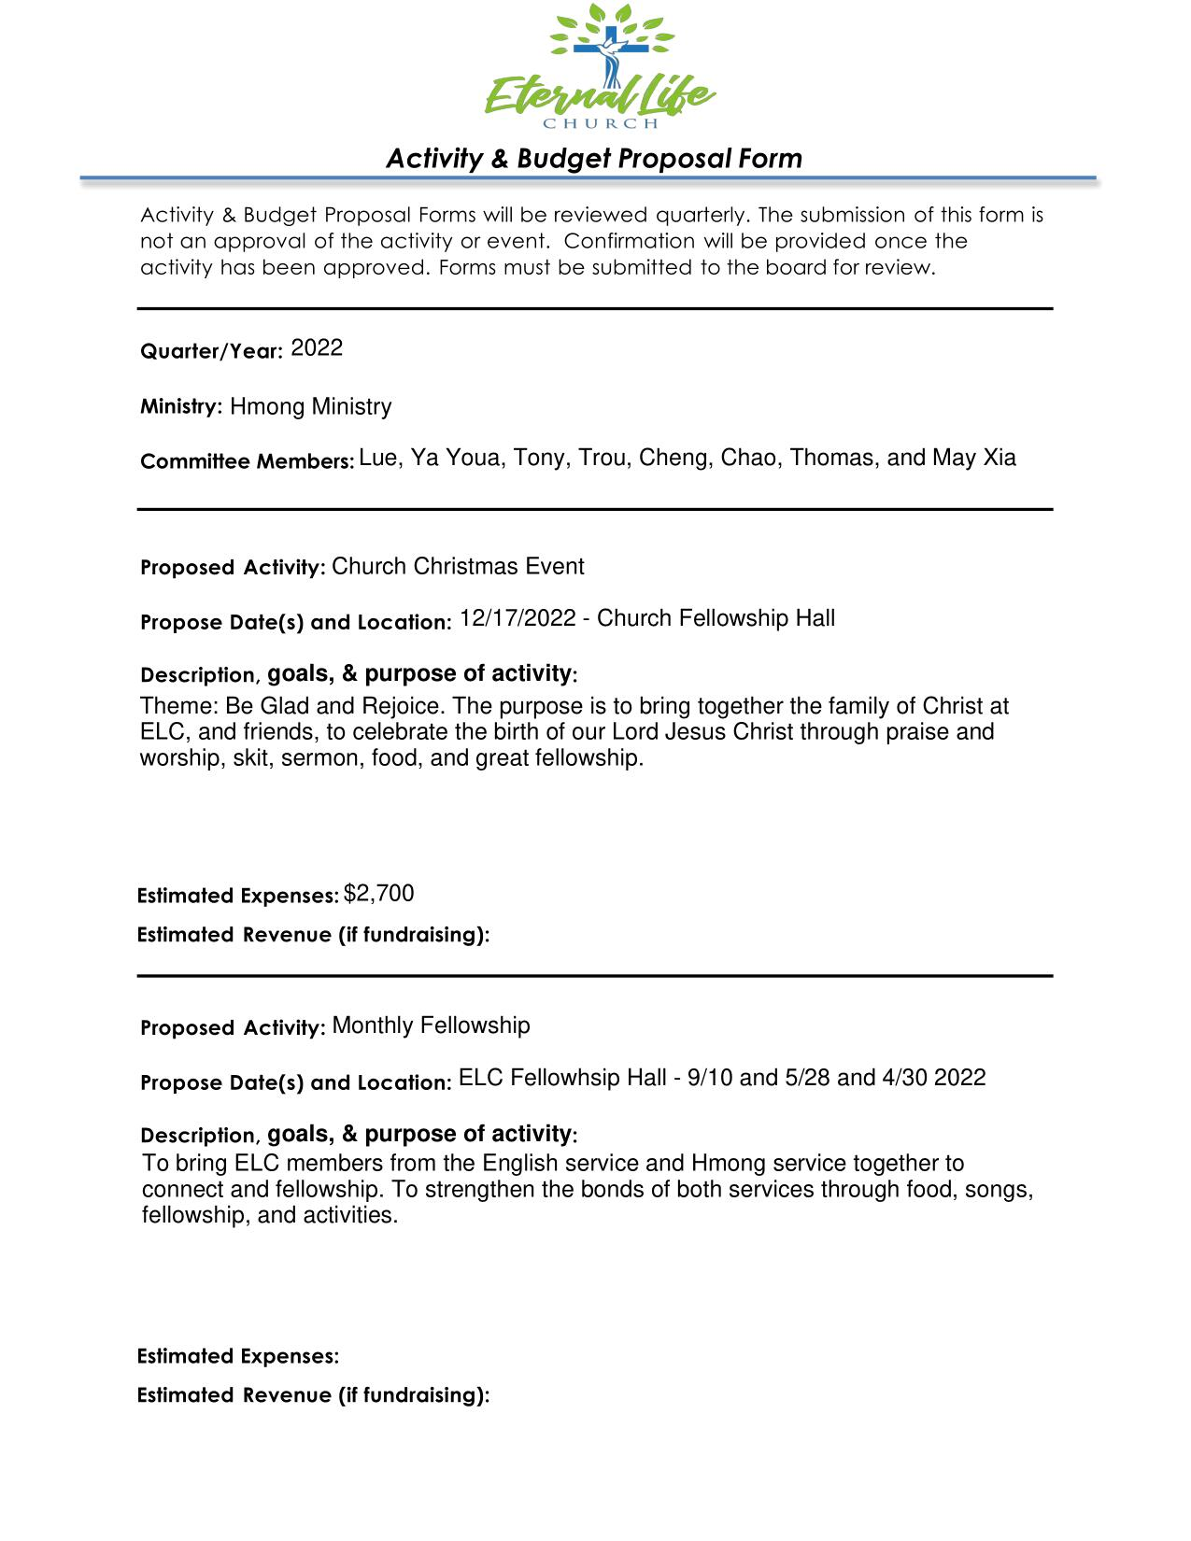
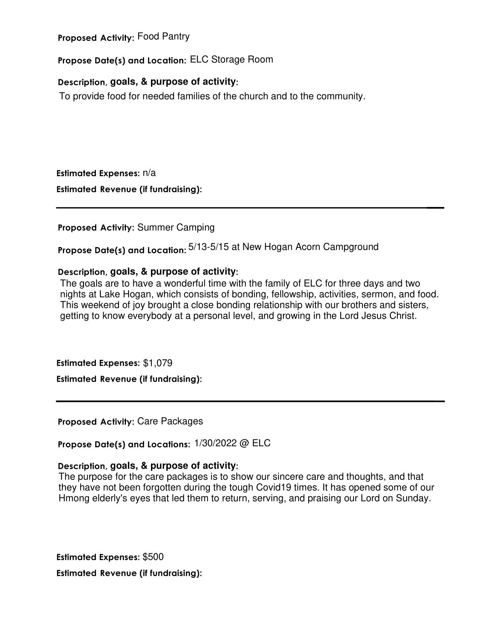

Children’s Ministry
Children’s Ministry Annual Report 2022
Committee Members:
Zoua Vang, Jennifer Heu, Ya Youa Xiong, May Cha, Lien Nguyen, Pang Xiong
Vision Of Ministry:
The purpose of ELC’s Children’s Ministry is to faithfully teach scripture and demonstrate the love of Christ to all children so that they will become disciples of Christ who trust, serve, worship, and obey Him now and into eternity.
Theme:
Encourage and empower children and their families to know Jesus and share His story. Support the development of a strong biblical foundation using Epic Teachings of the Bible curriculum.
Summary of Yearly Activities/Number of Attendees:
Children Events/Number of Attendees Summary of Event
January 2022
Teacher Training / Orientation
Attendees: Approx 10-15
● Dig-in Curriculum
● Covid Safety procedures
● Sanitation procedures
● Q&A
March 26th, 2022
Classroom Decorating
Attendees: approx 15 - 20
● Coordinator and Teacher
fellowship
● Team Building - decorating
classrooms
● Food provided by Coordinators
April 10th, 2022
Easter Service (Day 1 of 3)
Attendees: Approx 30 - 35 kids participated
● Children participated in Skit
(Triumphant Entry)
● Children sang special song
“Hosanna to the highest” lead by
Supporting Youth and Young adults Ministry
Jon Vue
April 16th, 2022
Children Easter Program (Day 2 of 3)
Attendees: Approx 30-40 Kids Participated
● Lunch prep and distribution:
Hotdog, Chips, Water
Supporting Youth and Young adults Ministry

April 23rd, 2022
Children activities during Farewell
Attendees: Approx 35-40 kids
Celebration for Pastor Daniel
● Dinner: Pizza, Chips, Water
● Activities: arts and crafts
Supporting Designated Committee with Event
May 29th, 2022
New Curriculum: Epic Teachings of the
Bible
Start of New Curriculum
July 10th, 2022
Transition Ceremony
● 6 CE Students Transitioned to
Youth
● Bibles given as gift
Ceremony during English service
● Cake provided
July 23rd, 2022
ELC Annual Picnic
Attendees: approx 35-40 children participated in
● Activities and games for CE
games and activities
Children
● Pinata
Supporting Men’s Ministry
August 5th - 6th, 2022
VBS
Attendees: approx 35 - 45 children - not
● Theme: HayDay: Growing in
including volunteers
friendship with Jesus
● 2 day event
● Provided Breakfast, Lunch and
Dinner
● Theme Messages given by May
and David Yang
● Activity Stations: Led by adult
volunteers
● Group Leads: Led by youth
September 24th, 2022
Pastor Christohper’s Retirement party
Attendees: approx 30 - 40 children
● Activities: Arts and Crafts
● CE performed two special songs
for the event
● Dinner provided: Pizza, Chips,

Supporting designated committee snack, drinks
November 20, 2022
Thanksgiving Banquet
Attendees: Approx 40-45 children
● Activities and games
● Movie and Popcorn
Event led by GG’s
December 17th, 2022
CE Christmas Program
Attendees: approx 30 - 35 Children
● Devotion by Pastor Ying on Birth
of Christ
● Special song performance led
Event Led by Hmong Ministry
by Toua and piano by Michael:
One Small Child, Away in a
Manger, What can I give him?
● Short Movie - Right Now
media-The Story of Christmas
● Popcorn Provided

Overall areas of success:
● Handled all events well and communications was great amongst eachother and volunteers.
Overall areas of needing improvement:
● Lack of teachers, in need of more teachers
Comments and Recommendations

Young Adults Ministry
Committee Members: Leaders: Jessica Yang, Kayla Moua, Jonathan Vue, Hydaeus Vang, Isabelle Kue

Vision Of Ministry:
Our vision for the young adult ministry is to provide a sense of belonging for the young adults, as well as to build up our relationships. Our focus also includes encouraging young adults to come back to the church and strengthen their relationship with God and his people.

Theme: Fellowship

Summary of Yearly Activities/Number of Attendees:

Events/Number of Attendees | Summary of Event
Date: Every 2nd and 4th Friday of the month @7-9pm at church in the conference room  Number of Attendees: About 7 | Event Name: Book Study  Summary of event: Young adults will do a bible/book study twice a month to build a relationship with each other and begin/strengthen their relationship with God. We read “River Dweller” by Rob Reimer. Purpose of this was to bring the young adults together and apply what is learned from the book to our lives, fellowship and grow with one another, dive into and reflect on our own relationship with God, and start a foundation between the young adults
Date: February 27th, 2022 @5-7pm at church in the multipurpose room  Number of Attendees: About 15 | Event Name: Boardgame Night  Summary of event: Boardgames, activities, and food was provided. The purpose was to have young adults gather and fellowship with one another, establish a better relationship with one another, provide an opportunity for young adults to open and learn more about one another
Date: March 27, 2022 @5-8pm at church multipurpose room  Number of Attendees: about 17 | Event Name: Arts and Crafts Night  Summary of event: This fellow was a summary of young adults who painted on canvas and tie dyed on plain white shirts together. We got to fellowship and get to know one another more as we participated in ice breakers, meals, and worship.
Date: April 24, 2022 @5pm at the Alley Bowling Center  Number of Attendees: about 15 | Event Name: Bowling Night  Summary of event: Young adults went bowling at the Alley as they got to fellowship
Date: May 29, 2022 @5-8pm in the CE building  Number of Attendees: about 17 | Event Name: Boba Movie Night  Summary of event: Young adults came together to fellowship by watching a movie called “Infidel.” Boba drinks, popcorn, and candies/snacks were provided.
Date: June 26, 2022 @5-8pm at church multipurpose room  Number of Attendees: about 22 | Event Name: Korean BBQ Night  Summary of event: Young adults fellowshipped together with a nice-chill get together. We got to fellowhsip through meat-grilling and eating, worship, icebreakers, and devotion led by Cheyenne.
Date: July 14-17, 2022 @ San Diego State University  Number of Attendees: about 20 | Event Name: SALT and Light Conference  Summary of event: Young adults drove all the way down to San Diego where we fellowshipped with all churches, single adults and young married couples. We dormed with one another, discussed in small groups, attended small sessions, witnessed baptism, participated in bowling/arts and crafts, sports activities, and attended morning and evening worship/sermon.
Date: July 31, 2022 @4 at Elk Grove Park  Number of Attendees: about 30 | Event Name: Welcoming of the New Young Adults  Summary of event: A celebration for the older youths who have completed high school. They are now entering as new additions to the young adult ministry. This fellowship was a time for the youth and young adults to come together and celebrate the leaving of older youths and coming of the new young adults through water activities, devotions, worship, and bbq at the park.
Date: August 21, 2022 @5pm at church multipurpose room  Number of Attendees: about 15 | Event Name: Potluck Fellowship  Summary of event: Young adults brought a meal to share at the table. We fellowshipped as we enjoyed meals, activities, worship, and devotion.
Date: September 25, 2022 5-8pm at church multipurpose room  Number of Attendees: about 15 | Event Name: Karaoke Night  Summary of event: Casual boardgame and karaoke with food provided to allow young adults to fellowship and grow closer with one another in Christ.
Date: October 29, 2022 at Dell’oso Family Farm  Number of Attendees: about 11 | Event Name: Pumpkin Patch and Maze  Summary of event: A fellowship that allowed young adults to fellowship outside of a church facility, but still in Christ. We picked pumpkins and participated in a corn maze as we got to fellowship and know each other a little more.
Date: December 10, 2022 5-9 at church  Number of Attendees: about 120 | Event Name: Night of Worship, Alive in Him  Summary of event: A worship night that invited all young adults and youths to come together to praise and worship God as a whole family. We got to break into small groups and share our testimonies with one another as we prayed and cried out for God. Food and snacks were provided and devotion was led by Pastor Christian.

Overall areas of success: Overall, the Young Adult Ministry couldn’t have grown our size without God’s work. The ministry came out to be a very successful ministry. We got to grow and get to know each other’s faith and walk in Christ. All these fellowships opened lots of opportunities for us to be vulnerable with one another as we kept God included in our discussions and activities.

Overall areas of needing improvement: Overall, the Young Adults Ministry could have reached out to MORE young adults. We were a shy and small team, but we did what we could. However, there is a lot of potential to do more.

Comments and Recommendations: N/A

Discipleship Ministry Annual Report

Committee Members:
P. Blong & Kao Zong Thao and Lee Lo & Toby Moua

Summary of Yearly Activities/Number of Attendees:

Events/Number of Attendees | Summary of Event
Number of Attendees:  - 1st cohort: 5 teachers, 20 ->18 students  - 2nd cohort: 1 teacher, 8 students | Christian Leadership Academy (CLA)  Summary of event  A compendium of pastoral theology, based on the Life of Christ from the Gospel of Matthew (150 lessons in 6 books). This course is a 2- to 3-year basic and integrated program to prepare Christian workers and leaders.
Number of Attendees:  - Mentors: Toby/Lee; Alex/Xeng; Tony/May; Fred/Jessica; P. Blong/KZ; May Cha; David/May; Hang/Serena; Louie Thao; Ying  - Mentees:  Completed: Saum/Nou (12/21); Nik/Bao (12/21); Nou/Cindy (1/22); Bee/Pang (3/22); Kyle/Sherri; Yee/Alex (5/22); Cheng/Chao (8/22); Thay Vang (10/22); May/Matthew (10/22)  In progress: Ka/Dia, Yia/Nicole, Xue, Leo/Amy, Mary/Tisha, Antoine/Kathy, Chris/Donna, Chwseng/Lien | Abundant Life (AL)  Summary of event  A basic course of 18 lessons on the foundations of the Christian life and how to live the ‘Abundant Life’ offered by the Lord.
Number of Attendees: 6  - Yee/Alex; Hang/Serena; Ger/Jennifer | Financial Peace (FPU)  Summary of event  A 9-lesson study on financial stewardship from Ramsey Solutions. We meet regularly in the CE building to watch and discuss how we have handled money and identify best practices for the glory of God.
Number of Attendees: 9 groups  - Alee/Solaeta  - Moses/Chee  - Tony/May  - Toby/Lee  - Se/Cho  - Fred/Jessica  - May/David  - Alex/Xeng | Small Groups  Summary of event  The purpose of the small group ministry is to connect people of faith in  - Maturing their relationship with Jesus (Eph. 4:13)  - Edifying each other through relationships and conversations about Jesus (1 Thess. 5:11)  - Inviting non-believers/new believers to hear/know Jesus (Rom 10:14)
Date: July 1-15  Number of Attendees: 6  - P. Blong, Kao Zong, Maria, Gance, Kou, Maikue | Envision Short Term Mission Trip  Summary of event  In collaboration with Envision Bangkok, the team went on a 14-day short-term mission trip to Thailand. In Thailand, the team  - Went to a Hmong village in which we visited and prayed for 3 families  - Visited and heard about the ministry of the dormitory Little Lamb  - Led VBS for the neighborhood around Deeper Life Church  - Visited and prayed over the Red Light District ministry: Rahab  - Connected with Thai believers and nonbelievers
Date: September 15-17, 2022  Number of Attendees: 6  - Lee; Toby; Kou, Maikue; May; Kang | Soul Care Conference - Pacific Grove, CA  Summary of event  Based on Dr. Rob Reimer’s book SoulCare, this conference focuses on learning and working through steps to care for our whole being. Topics of focus include:  - Identity/Overcoming Lies About Yourself  - Repentance  - Breaking Family Sin Patterns  - Forgiving Others  - Healing Wounds  - Overcoming Fears  - Deliverance
Date: November 4-6, 2022  Number of Attendees: 18 | A Weekend To Remember Conference - Monterey, CA  Summary of event  - Find lifetime tools to strengthen your relationship—no matter how firm or fragile  - Hear engaging talks from marriage experts  - Get alone with your spouse in guided, practical-application projects. Create wow-level memories
Date: October 29, 2022  Number of Attendees:  - Volunteers: 100  - Participants: 175 | Harvest Festival  Summary of event  - This event was themed on the life of Moses. Parents and children who participated learned about the birth and life of Moses. There were two small lessons, one at the beginning and one to conclude. The majority of the time, the children were broken into groups and learned about the different major events of Moses’ life at each of the 10 stations.

Fellowship Ministry

Audio and Visual

Committee Members:
Peng Her
Michael Yang

Vision Of Ministry:
The vision of the AV ministry is to support other ELC ministries on and off campus which can free ministry leaders to focus on their ministry and not the technology. This can be accomplished by installing equipment that simplifies

Theme:
NA. AV is a ministry that provides support.

Summary of Yearly Activities/Number of Attendees:
AV ministry has provided support for both ELC Worship services (Hmong, English) every Sunday in 2022. Furthermore, AV provided support for all the worship team practice sessions throughout 2022.
English worship team on Tuesday night at 7pm – 9pm
Hmong worship teams on Thursday from 7pm-9pm
Night of Worship
Heavenly Harvest
Special occasions throughout 2022.

Provided audio support for the following outdoors event. Audio equipment was transported and set up.
Annual picnic – Ancil Hoffman Park
Thanksgiving Diner – Citrus Heights Community Center
Overall areas of success:
Sunday Services has been operating as planned. Volunteers new to AV are given an opportunity to run both Audio and Video during services. Setup outside of ELC continues to be coordinated and led by Peng and Michael.

Ministries have been great at communicating their AV needs this year. AV has been able to better prepare for ministry events.

Overall areas of needing improvement:
Overall, the ministry is running smoothly. Volunteers are feeling more comfortable with the technology and are willing to run Sunday Services with some supervision. However, more volunteers are needed to give relief to the current group.

Comments and Recommendations
In an effort to get more volunteers and further smooth out the services, AV will be simplify and streamline all processes from the soundboard to the stage. We have already purchased much of what is needed but there are still some equipment that is needed. Currently, in the sanctuary the on and off procedure for the AV booth and the stage is a multistep process that’s required for the equipment to operate properly. The concept for improvement is to be able to flip one switch and turn on all AV and stage equipment. The same switch will also turn it all off. Peng and Michael will set up a process for how to operate and all volunteers will follow the same procedure. We will work with the Worship team in order to make the process easier for the volunteers.

Praise & Worship Ministry

.

Safety and Security Ministry
Committee Members:
English Service: Alee Xiong, Ger Vang, Xeng Her, Tua Vang, Yee Xiong, and Bee Yang

Hmong Service: Tom Yang, Chou Lee, Fue Vue, Thomas Yang, Moua Lee, Va Chang Lee, Lue Thao, Blong Lee, and Donnie Her

IT/CCTV: Ger Vang

Mission and Vision of Ministry:
We are committed to providing safety and security services for all who worship at Eternal Life Church (ELC). The primary purpose of this Ministry is to maintain a peaceful, safe environment which is conducive to teaching, learning, working, living, and sharing in the Word of God.

Summary of Yearly Activities:
This year the campus was fully opened for in-person services, which called the team to resume our normal duties.
AB506 was effective January 1, 2022, which requires administrators, employees and volunteers age 18 or older who are in contact or supervise children and youth to complete mandatory child abuse and neglect training. AB506 is new law that requires a live scan of each person, which entail fingerprinting and a background check. It also requires us to put together our own policy to prevent and properly respond to child abuse.
In addition to the AB506 policy, this year other policies are also being put together by this ministry team for review and approval as we move into the new year pertaining to emergencies, medical or other.
In 2022, we continued to experience cases of trespassing and theft. There were a few encounters with trespassers who displayed passive aggressive and unpredictable behavior. Fortunately, we were able to resolve these situations on our own without the involvement of law enforcement. We also had two incidences of theft. The items taken were food and plants.
This year provided opportunities for us to meet, get to know and witness to the homeless in and around our campus. There were homeless individuals that came to our campus for food and water. We provided them food, water, words of encouragement and prayers.
We continue to experience violent crimes outside of our campus. There were two reported shootings. We were asked to assist local law enforcement officers and homicide detectives with evidence to assist with their investigations. We provided CCTV footage pertaining to one of the incidents to the homicide detective investigating the case.
Furthermore, we requested for a few more cameras this year to cover the main office area where the ushers count and to cover the entrance leading to the pastors’ offices and restrooms for enhanced security.
To conclude our yearly summary, we also had the opportunity to serve other ministries. We provided safety and security services for Vocational Bible Camp, Easter, Pastor Appreciation, Heavenly Harvest, Turkey Drive and Clothing Give-Away, Mission Conference, Night of Worship, Christmas Dinner and Appreciation Dinner.
Overall areas of success:
God was able to use us to serve each other and our congregation without incident this year.

Overall areas of needing improvement:
Communication and understanding.

Recommendations:
Training in church security for the team via online or in-person courses.
Training in CPR/First Aid, Active Shooting, verbal de-escalation and or physical intervention skills for the board, ministry leaders and security team.
Mandatory Child Abuse and Neglect AB506 training for all leaders including anyone 18 of age and older who has contact or supervision over our youth and children.
Equip team with fish kits and pocket bibles for the needy and homeless.

Usher Report
Coordinator: Lue (Louie) Thao

Summary: This past year we had our counters train with Vameng Thao to learn the recording process. We trained many new ushers on their ushering duties: passing collection bags and ushering people to their seats. It was productive when people showed up for their duties but it seemed like I was working a lot. But as a coordinator that is what I do.

Auditor’s Report