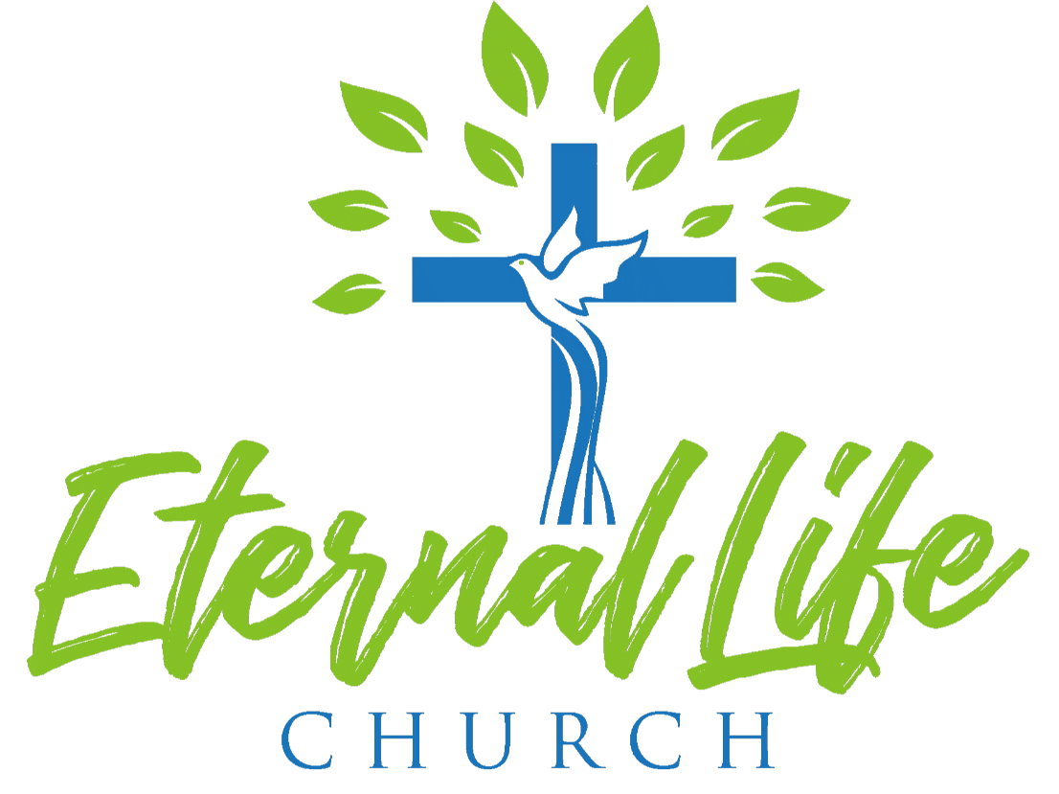
Board Meeting Summary
April 9th, 2022
_______________________________________________________________________________________________________

The Board met on April 9th, 2022. Pastor Christopher shared a devotion and scripture from Matthew 23:1-4. Then he lifted up prayers to begin the meeting. The agenda was reviewed and approved.

The Board received the March financial report from the treasurer. The total income was $32,145.72; the total expense was $32,965.40, with a total bank balance of $244,315.49.

The Board received an update on the CD investment. The Board decided to proceed with investing the $50,000 into a new separate CD.

The Board received news that the Haspanic Church will begin meeting in May 2022 in the CE building after 1pm.

The Board received an update on the CPD District Conference, Encounter, happening May 2-4, 2022. They will be renting a house instead of staying at a hotel to save on cost. Attending the conference will be Pastor Christopher Thao, Kao Zong and Pastor Blong Thao, Pa ia and Jerry Lo, and Pastor Kongchinh.

The Board received and postponed a decision on a Quickbooks upgrade. Option 1 allows for more than one user but has a monthly cost of $235 for the first year and then $319 after the first year. Option 2 only allows one user but is available online and has an annual fee of $860.

The Board received an update on Pastor Daniel Yang’s Farewell Party. An agenda was presented for the event set for April 23, 2022 at 4pm. After the service a dinner will be served with an open mic session.

The Board received and reviewed the proposal for the automatic gate and postponed a decision. They are asking Church Management, Kong Yang, to look into the regulations and make recommendations about which gate to automate.

The Board discussed and approved a total budget of $1859.00 for the Young Adult’s transportation cost to the Salt & Light Conference in San Diego. This will cover 6 seats on the shuttle bus with SHAC and fuel for 4 cars.

The Board received and approved GG’s (Women’s Ministry) raffle fundraiser request.

The Board discussed and approved 4 of the 5 requests to fundraise from the Youth Ministry team for their upcoming retreat on June 24th-26th. Fundraisers approved were: Letters of Donations, Yard Work, Coin Drive and Sneaker Donation “Got Sneakers”. Their request for funds to pay for the 6 chaperone’s fees of $786.00, as well as, for the $200 nonrefundable deposit was also approved.

The Board received and approved Board Member Kou Khang’s request to update the Church Rental Agreement.

The Board received an update about the Hmong Praise and Worship team’s concerns that they have not been contacted since December 2021. The Hmong Ministry Worship leader says the teams are still intact and needed. Board member Vam Tou Moua will further discuss this issue with her.

The Board received an update on the Hmong District Conference. Cho and Se Kue, Tony Lee and Trou Yang have registered to attend. Soleata Chan will look into booking flights and hotel accommodations for them.

The Board considered the suggestion to host a new member luncheon. It was decided that we will continue as before with making ourselves visible and available to meet and greet new and existing members during fellowship and before service.

The Board received an update on the Pastor Succession Process. Pastor Albert Vang visited in 2021. Pastor Christian Vang visited us on November 20, 2021 during our Thanksgiving Event. Pastor Jason Yang visited us on February 20th, 2022. Pastor TouLia Yang visited us on March 27th. Pastor Daniel Moua will be visiting us on April 17th, 2022 for our Easter Service. Pastor Dao Vang will be visiting in May 2022. On June 11th the Board will consider if there are any candidates they want to move forward with. Their names will then be submitted to the district. The board will also see feedback from the congregation. There is no timeline of when the succession will happen. If we cannot find anyone this process can continue on. Pastor Christopher will stay on until a new Senior Pastor is found.

