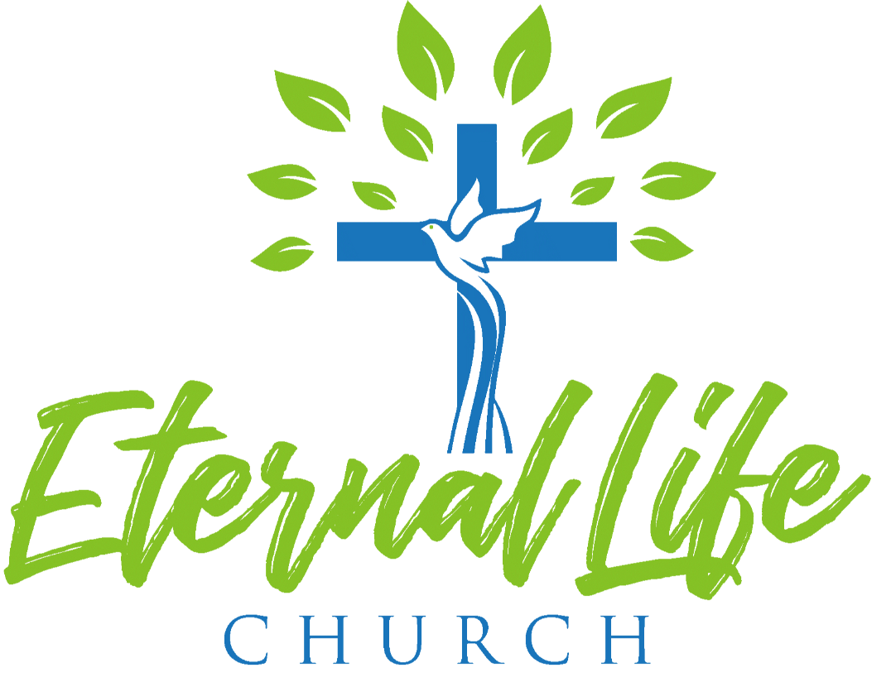

2021 Annual Report

Pastor Annual Report

Introduction:
1 Corinthians 3:5-7 (NIV) reads: What after all, is Apollos? And what is Paul? Only servants, through whom you came to believe-as the Lord has assigned to each his task. I planted the seed, Apollos watered it, but God made it grow. So neither he who plants nor he who waters is anything, but only God, who makes things grow.
This passage pretty much sums up the year 2021. While our ministries have returned to some normalcy, we have not fully returned to normal. Social distancing remained in place for the most part and masking has become a norm of sort. Even so, we thank our heavenly Father and the Lord Jesus for blessing us throughout 2021. Giving has increased and membership has grown through newborns, membership transfers, and converts. We had several members and non-members who committed their lives to the Lord through baptism.
How many churches have the privilege of developing men and women for the Great Commission? Yet, we had Pastor Blong Thao and his wife. Moreover, the church strived to begin planting a daughter church with Jerry and Pa Ia Lao. Praise the Lord.
Most importantly, we have embarked on a succession process. In the last decade since we came into existence, we went through two successions: From Pastor Mark Hitman, the church planter, to Pastor Daniel Yang; and from Pastor Daniel Yang to me. We don’t have a plan, and we need one. In this report, I will address that, too.

Growth is of God
Last year we have had a remarkable growth. More than ten (10) families have joined ELC. Numeric growth speaks to the number of people who made commitment to have fellowship with us. We thank God for each of them. Most of them have friends or families in the church, making the transition easier. We need to plug them into ministries so that they can learn and grow in their walk with Jesus.
We lose a member, who had gone to be with the Lord. Chong Lee has been with us soon after we moved to our current location (2020). Her brothers were members of our church, but she was a new convert. She was ill with kidney failure and the doctors couldn’t heal her, but the Lord made her whole.
Attendance and giving have also grown. In the beginning of the year, we were completely on live streaming. But we slowly open for in-person worship. By May 9, 2021, we had 41 in attendance for Hmong Service and 129 for English Service. Attendance fluctuated in the summer and fall, but by October 10, it has stabilized. We are back to 180-200 in attendance.
As for giving, we budgeted $300,535 and received $389,453, which is $88,918 above budget. The youth fundraising has been impressive. They raised over $16,000 for HLUB.
Discipleship continued despite Covid19. We had a group of CLA graduates in 2021 and more are to come. Pastor Blong and Lee Lo are working diligently to enlist church members to take the class on the life of Christ. But discipleship does not occur in the classroom or worship services only, it takes place in small groups. We have several lively small groups and ministry groups, where life transformation take place. Transformation is not dramatic, so we can’t point them out in annual reports; but it is a process of stripping away the old self, in and through daily reflection and living with other believers. Simultaneously, the Holy Spirit works quietly in us and besides us to conform us to the image of Christ. As you look around, you see brothers and sisters who have been changed in the years they have been part of ELC.

Significant Occurrences
Preaching is an integral part of worship. The pastors have spent 2021 preaching through the Torah (Genesis-Deuteronomy), the historical books (Joshua-Esther), wisdom literature (Psalms-Song of Songs), and the major prophets (Isaiah-Ezekiel), and now in the middle of the minor prophets (Daniel-Malachi). The pastors will continue until they complete the whole Bible.
In the beginning of 2021, two things happened. First, Jerry Lao has completed his biblical studies at Toccoa Fall College and is passionate about church planting. The Board approved his (and his wife’s) request to organize a small group, whose purpose is to plant a daughter church. Jerry and Pa Ia went through the C&MA church plant assessment and will be involved in other seminars and training in the days to come. The team will probably go to a bootcamp for church planters in the coming months.
Second, Pastor Blong Thao and his wife, approved candidates for the Great Commission, joined us. They came to us from the national office and the district. They are completing their home assignment (ministry experiences) and ordination (for Blong), both of which will take 2-3 years. They are assigned to the church planting small group and discipleship ministry.

Succession Planning
By far the most difficult thing for us as a church is the succession process, which the board discussed in the fall. Every pastor will retire or move on at some point, because he is a servant of Christ; but the church ministries go on. We need a plan to hear God, to see his hand working among us, and to find replacement so that the works of the church will not be affected negatively. This is especially true for the lead pastor.
Talking to Pastors Mark Hitman and Daniel about the previous succession processes, I can summarize them as follows: First, the pastors discussed succession need with the advisory team (Mark’s case) or the governing board (Daniel’s case). Consultations were made with the district office. Names were suggested and out of them, the pastor made calls to the best candidates and invited them to come. Second, with the advisory team or board and the district superintendent consent, the pastor presented the call to the successor. Once the call was accepted, the successor came and was installed. These tasks were done in prayers, seeking God’s favors for the church.
As we move forward, the process will be slightly modified. The primary problem for us is that ELC is a bilingual church and the pastor needs to be able to speak and preach in Hmong and English. While most Hmong C&MA pastors are in the Hmong District, we belong to the Central Pacific District and our board members don’t know a lot about pastors in the Hmong District. If we go outside of our denomination, and we can, the candidate must be approved by the C&MA (through the District) before we can call.
With these challenges, I prayerfully took on myself the difficult task for creating a pool of potential candidates, from which we may invite to visit us. We are in this process now, the board and I. When we find a good candidate, I will invite him (and his wife) to visit us and to preach. You will have the opportunity to meet, greet, and know him. Hopefully, you can ask questions as well. I am in regular contact with other pastors and the superintendent of Hmong District. Please pray for me and the board.
If and when the board is satisfied with a candidate that he is the chosen shepherd for the church, then we move to the second step: to bring his name and credential to our district (CPD) superintendent. And if he approves, then the board will offer the call to that pastor to come. Either me or our vice chair will relay the call to the new pastor. Should he accept the call, arrangement will be made for his installation.
Some of you have asked about a timeline. I don’t know, but God knows. Let us seek God in this because his time is perfect. God never makes mistake.

In Christ,
T. Christopher Thao

Associate Pastor Annual Report

As associated pastor, I was privileged to preach on Ruth, Esther and Hosea. I preached at funerals and visited and prayed for the sick. I attended Men’s events. As the person on campus, I opened gate, closed gate; and I secured the sanctuary and rooms after worship. On Sundays, when I was not sick, I collect trash around the property so that the facility would be presentable when the Lord walked in.

Missions ministry: we were able to for the first time bring a Jewish believer and his wife to minister to us for missions conference. Also the team coordinated a rice drive giving away over 80 bags of rice to those in need, but primarily the Afghan refugees.

All these things came to us by the hands of God and were done for Him through His grace and we praise Him. It is a joy to be a part of the Eternal Life pastoral team.

Pastor Daniel Yang

Youth/Single Adults Pastor Annual Report

One of the main objectives for the year 2021 was to send our students to Hlub camp. This year, Hlub camp was help in Indiana State University in Terre Haute, Indiana. As for attendees, we had a total of 35 students registered for the camp. In addition, we decided to send myself along with our two coordinator couples to help chaperone the trip. In total, we had the objective of sending 40 individuals to attend Hlub camp.

2021 Events: Of course, with Hlub camp being our main focus this year, one of the main focus for a lot of the events this year was raising funds to help cover the cost of airfare. With that being said, though we had to spend a good amount of time focused on raising funds, we wanted to do so in a way where our youth would be able to fellowship and build relationships as well.

- Yard Sale
Because I’m sure we all have a lot of things around that house that we were trying to get rid of at some point in time, we decided to have several yard sales to where we could at least get something in exchange for the things we were wanting to get rid of. We help yard sales at three locations: Fred & Jessica’s home in Rocklin, David & May’s home in Elk Grove, and our church facility in Sacramento. Items that we were unable to sell were then donated to Goodwill.

2. Yard Work
Throughout the year, the youth partnered up with individuals to clean yards, and in return would receive monetary donations for their Hlub trip. Alongside of the yard work, the youth’s presence was requested to help set up and tear down certain events help by church members for a similar donation.

3. Recycling
For our recycling project, the youth had the task of asking family members for their cans and bottles, then for several months, the youth spent hours sorting and organizing the cans, which would later be recycled. Though early on did not seem very profitable, actually became one of our main driving forces in our fundraising efforts.

4. Raffles
One avenue the youth wanted to explore this year in terms of fundraising was through raffles. Thanks to the generosity and donations from many church members, the youth had enough gifts to raffle. Friends and family were able to purchase raffle tickets for specific items and based on how many tickets they purchased, they received a specific number of golden tickets for the big ticket item at the very end of the raffle. Overall, a very successful means to fundraise.

5. Youth Fellowship
Every last Friday of the month the youth leadership team hold a fellowship at church.
Here, the youth take part in games and activities, worship, and a devotion.

6. Hlub Camp
This year Hlub camp was help at Indiana State University in Terre Haute, Indiana. With our fundraising efforts along with a generous donation from the board, we were able to send 35 students Hlub camp alongside our 5 chaperones. Here, the youth were able to take part in corporate worship and classes designed to strengthen one’s faith.

Symon Yang, a nephew of May and David felt the Lord’s calling in his life and decided to give his life to the Lord, being our only student to be baptized at Hlub camp.

Youth Service:
Since the Covid restrictions have been lifted, youth services were able to be go back to normal. Every first week of the month, the youth join the English service and take part of communion together. Weeks 2-5 youth services are held on Sunday’s simultaneously as the English service is in session.

In addition to our youth service, the youth also meet every Wednesday night for prayer and fellowship.

Leadership: One of the more significant changes for 20201 was the development of the youth leadership team. This team was created to help give the youth members the chance to develop leadership qualities and experience. This team works closely with pastor and the youth coordinators to help plan, organize, and carry out events and fundraisers for the year.

Youth Leadership Team:
Historian: Taying Thao (rotating out)
Secretary: Isabelle Moua (rotating out)
Male Chaplin: Skyler Vue
Female Chaplin: Maya Thao (rotating out)

New Addition: At this current time, we are still looking to fill our youth leadership team for 2022.

Along with the development of the youth leadership team, youth coordinator positions were also created to assist the pastor with the ministry. The youth coordinator positions are open to 2-3 couples who have a passion to serve the young people in the church.

Youth Coordinators:
Stephen & Gance Vue (rotating out)
David & May Yang

New Addition: We are currently looking for another one to two couples to serve alongside David and May as youth coordinators for 2022.

Men’s Ministry

Committee Members:
Moses Thao, John Yang, Hang Xiong, and Ger Vang

Vision Of Ministry:
Working as the body of Christ to faithfully serve and build up our fellow brothers and neighbors at ELC by reciprocating the love He has given us and sharpening each other through scripture, testimonies, and devotions as we’ve gathered for our events throughout the year.
Events/Number of Attendees | Summary of Event
Date: April 24, 2021  Number of Attendees: Youth, Hmong Ministry, & Men Ministry – approximately 80 | Men’s BBQ & Spring Cleaning  - Cleanup and landscaping around the church.  - Provided BBQ lunch & drinks.
Date: May 22, 2021  Number of Attendees: Varied – approximately 20 | Summer Car Maintenance  - Basic car maintenance: oil/air filter change, etc.  - Fundraiser for Youth HLUB trip.  - Provided BBQ lunch & drinks.
Date: July 24, 2021  Number of Attendees: Youth, Men Ministry & Children | ELC Men’s Hiking: Twin Lakes Trailhead  - Whole day hike & lunch.  - Provided lunch and drinks.
Date: September 11, 2021  Number of Attendees: Varied – approximately 60 | Men’s Ministry Recreation Day  - Partnered with GGs  - All day picnic & recreation.
Date: December 11, 2021  Number of Attendees: Men & some Youth – approximately 35 | Men’s Ministry Christmas Celebration  - Christmas fellowship with songs, praises, devotion, games, and dinner.  - White Elephant Gift Exchange
Date: December 19, 2021  Number of Attendees: Varied – approximately 250+ | ELC Christmas Celebration  - Organized agenda and coordinated with a variety of ministry teams to provide special songs, video/slide of children, and lunch for Christmas.  - Message from Pastor Christopher.

Theme:
Be Christ Like – Inspire, encourage, and support ELC men and neighbor for spiritual growth and help each other to understand what it means to be more Christ like, as He sacrificially served us all with mercy, grace, and love.

Overall areas of success:
- Overwhelming support from other Ministry teams and accomplished most of our desire goals as a team.

Overall areas of needing improvement:
- Providing advance notice of events.
- More ideas or ways to encourage all men, including new ones, to join us for fellowship at future church events.

GG’s -Women’s Ministry

Committee Members: Serena Xiong, Xeng Her, May Chang-Yang, Pa Vang
Vision Of Ministry: Helping to renew and/or strengthen the faith of our Ladies at ELC by having Bi-monthly or monthly gatherings (in-person or Zoom) to include personal devotions and activities that go along with our themed monthly biblical challenges.
Monthly challenges to help encourage faithfulness-
February- Resilience
March- Kindness
April- Gratitude
May- Courage
June- Integrity
July- Trust
August- Prayer
September- Confidence
October- Obedience
November- Commitment
December- Praise
Also, fellowshipping outside of ELC in a more casual environment (COVID permitting)
Theme: Faith
Hebrews 11:1 Now faith is confidence in what we hope for and assurance about what we do not see.
Galatians 2:20 I have been crucified with Christ and no longer live, but Christ lives in me. The life I now live in the body, I live by faith in the Son of God, who loved me and gave himself for me.
Matthew 9:2 Some men brought to him a paralytic, lying on a mat. When Jesus saw their faith, he said to the paralytic, “Take heart, son; your sins are forgiven.”
Hebrews 11:6 And without faith it is impossible to please Him, for whoever would draw near to God must believe that He exists and that He rewards those who seek Him.
Summary of Yearly Activities/Number of Attendees:
Events/Number of Attendees | Summary of Event
Date: 2/19/2021  Number of Attendees: 10-15 | Event Name: GG’s 1st Gathering (Virtually)  Summary of event: Held via Zoom. Pa Vang led the virtual gathering. We had prayer, introduced new GG coordinators (Serena & Xeng), devotion and summarized 2020 and 2021 GGs events.
Date: 2/20/2021  Number of Attendees: All 4 GGs coordinators | Event Name: Sua & Jeskia’s father’s death  Summary of event: GGs Coordinators posted and collected love offerings from other GGs. GGs coordinators visited Sua and Phit’s home to give our condolences, pray for her and her family, provide a pre-made meal and present them with the love offerings from GGs.
Date: 3/27/2021  Number of Attendees: 15-20 | Event Name: GG’s 1st Gathering  Summary of event: Held at ELC. May/David led the gathering. We had P&W, devotion, prayer, spiritual and fellowship activities followed by lunch.
Date: 4/2/2021  Number of Attendees: 15-20 | Event Name: GG’s Easter Basket Creations for HLUB Fundraiser  Summary of event: Held at ELC. Donations for Easter baskets provided by GGs, church members and Children’s Ministry leftover Easter items from previous years. About 40-50 baskets were created. All pre-made baskets sold out and more had to be created on the day of the fundraiser event. GGs made $977.00 towards the Youth HLUB conference.
Date: 4/13/2021 - 6/15/2021  Number of Attendees: 5-10 | Event Name: GG’s Walk Club  Summary of event: Held at Elk Grove Regional Park. Provided COVID safe way to fellowship and promote a healthy living.
Date: 4/24/2021  Number of Attendees: 20-25 | Event Name: GG’s Hiking Trip  Summary of event: Held at Hidden Falls Regional Park. Xeng Her led the outdoor activity. We had light snacks, prayer and fellowship.
Date: 5/7/2021  Number of Attendees: 10-15 | Event Name: GG’s Mother’s Day Basket Creations for HLUB Fundraiser  Summary of event: Held at ELC. Donations for Mother’s Day baskets provided by GGs and church members. About 20-30 baskets were created. All pre-made baskets sold out on the day of the fundraiser event. GGs also provided a rose for each basket purchased. GGs made $740.00 towards the Youth HLUB conference.
Date: 5/28/2021  Number of Attendees: 5-10 | Event Name: GG’s Graduation Leis Creations for HLUB Fundraiser  Summary of event: Held at ELC. GGs provided the candy for the leis. May/David provided the ribbon leis. About 20-25 candy leis were created and about 10-15 ribbon leis. All pre-made candy leis were sold out on the day of the fundraiser event. About 4 ribbon leis remained, but used for CE’s promotion celebration. GGs made $600.00 towards the Youth HLUB conference.
Date: 5/22/2021  Number of Attendees: 25-30 | Event Name: GG’s Garden Gathering  Summary of event: Held at Serena & Hang’s home. Serena Xiong led the casual garden gathering. We provided dinner, devotion, prayer, P&W and spiritual activities. We provided a nice and safe environment for the ladies to share any worries, anxious or hardship that had been weighing on their hearts.
Date: 6/13/2021  Number of Attendees: 20-25 | Event Name: ELC 10 Years Anniversary Celebration  Summary of event: Held at ELC. GGs asked to help with food prep, cooking and packaging.
Date: 6/18/2021  Number of Attendees: 5-6 | Event Name: GG’s Father’s Day Basket Creations for HLUB Fundraiser  Summary of event: Held at ELC. Donations for Father’s Day baskets provided by GGs and church members. About 15-20 baskets were created. All pre-made baskets sold out on the day of the fundraiser event. GGs made $514.00 towards the Youth HLUB conference.
Date: 6/26/2021  Number of Attendees: 10-15 | Event Name: GG’s Wood Workshop  Summary of event: Held at ELC. May/David led the activity. We provided light brunch, devotion, P&W. Crafted personal/favorite scripture onto a wood board for keepsake. Great reminders of God’s love for us.
Date: 7/31/2021  Number of Attendees: 30-40 | Event Name: Son’s & Daughter’s Appreciation Dinner coordinated w/ Youth & Men’s Ministries  Summary of event: Held at ELC. Dinner was held to show appreciation for church, family and friends for their spiritual, monetary and physical support during the youth fundraising for HLUB conference.
Date: 8/25/2021 - 10/13/2021  Number of Attendees: 5-10 | Event Name: GG’s Retreat Recycling Fundraiser (Sorting Event)  Summary of event: Held at ELC. Recyclables donated by church members, friends and family. GGs sorted and turned in recyclables, earning a total of $1,229.11.
Date: 9/11/21  Number of Attendees: 25-30 | Event Name: Picnic Event coordinated w/ Men’s Ministry  Summary of event: Held at William B. Pond. Both Ministries provided food, games and outdoor physical activities (football, cycling, volleyball, fishing, etc.)
Date: 10/10/2021  Number of Attendees: GG’s Coordinators | Event Name: GGs Retreat Papaya Fundraiser  Summary of event: Held at ELC. Papaya was left over from the Youth HLUB fundraiser. GGs earned a total of $790.00.
Date: 10/22-24/2021  Number of Attendees: 36 | Event Name: GG’s Retreat  Summary of event: Held at Diamond Arrow Christian Conference Center. Serena Xiong spearheaded the retreat (calling facilities, coordinating dates, food, lodging, booking). Other coordinators assisted in fundraising, agenda, sleeping arrangements, and activities. May/David & Pa Vang gave devotions, led P&W & icebreaker activities and games. MaiKue & her sisters led a jewelry making activity. Lee Lo, Alex Xiong and Xeng Her gave personal testimonies. We went on a guided tour. Meals were prepared by the facility, but GGs provided light snacks and water at the cabin. Every lady in attendance was given the opportunity to ask for praise or prayer requests, which then a GGs coordinator would personally pray for them. GGs coordinators made and gifted tote bags that included a personal Hydro flask.
Date: 10/30/2021  Number of Attendees: 50-60 | Event Name: Heavenly Harvest  Summary of event: Held at ELC. Assigned by ELC Board to host the event. GGs coordinators reached out to the congregation for candy or monetary donations. Prepared and organized games, activities, candy, traffic flow, parking and the CE building and parking lot. Requested help from the Youth Ministry to help operate the 10 activity stations, CE Ministry to assist with P&W and short devotion, AV Ministry for music and videos, & Security Ministry to help man the gates, traffic and parking. Provided lunch for the volunteers.
Date: 11/10/2021  Number of Attendees: 5-10 | Event Name: Chong Lee Funeral  Summary of event: Held at Moon Sun Memorial Services. Asked by the ELC board to assist Chong Lee’s family in catering and packaging the food for the funeral service.
Date: 11/20/2021  Number of Attendees: 50-60 | Event Name: ELC Thanksgiving Dinner coordinated by Hmong Ministry  Summary of event: Held at ELC. Asked by the Hmong Ministry to help cook turkeys and package food for the event.
Date: 11/21/2021  Number of Attendees: Serena Xiong | Event Name: Pastor Christopher’s sister’s death  Summary of event: GGs Coordinators posted and collected love offerings from other GGs. Serena Xiong and her husband (Hang) visited Pastor Christopher and Sylvia’s home to give our condolences, pray for them and their families and present them with the love offerings from GGs.
Date: 12/1/2021  Number of Attendees: All 4 GGs coordinators | Event Name: Soua Kurk’s father’s death  Summary of event: GGs Coordinators posted and collected love offerings from other GGs. GGs coordinators visited Soua and Ryan’s home to give our condolences, pray for her and her family, provide a pre-made meal and present them with the love offerings from GGs. Soua’s 2 sisters were in attendance as well.
Date: 12/18/2021  Number of Attendees: 20-25 | Event Name: GGs Christmas Banquet  Summary of event: Held at ELC. Pa Vang led the Christmas Banquet. GGs prepared the food, decorations and photo backdrop. P&W, prayer, devotion, fellowship, raffle prizes and gift exchange games played. Goodie bags given to all in attendance.

Overall areas of success:
GGs Retreat was well received by the board, coordinators, ELC Women and Christian and non-Christian friends and family. Coordinators really saw God’s hand in all aspects of preparing, organizing and throughout the retreat. ELC Women and their guests experienced the Holy Spirit, shared their heavy hearts/burdens and a Godly sisterhood was created.
Heavenly Harvest had a great turn out.
GGs and other members of our congregation experienced deaths of loved ones this year. However, with the support and outpour of prayers, love offerings and acts of service, these ladies and the other members of our congregation felt and were shown God’s love.
Overall areas of needing improvement:
GGs regular attendance to gatherings vs special occasions.
Reaching out to GG visitors or new members
Comments and Recommendations:
GGs coordinators meet monthly to discuss gatherings, activities, special assignments, check in with regards to the spiritual needs of other GGs, prayers, feedback and overall health of our ministry.
God had a divine plan for Pa Vang, Serena Xiong, Xeng Her and May Chang-Yang as a whole. God had something for us to do and he blessed us with the talents, gifts and abilities to bring him glory and honor. 1 Corinthians 12:14, "For the body is not one member, but many.”
Recommendations-
- Try to know who the new coordinators are prior to the new year
- Inform new GGs coordinators of Budget & Reimbursement forms
- Inform new GGs coordinators there will be an end of the year report, so better record keeping can be done in advance.

Hmong Ministry

Committee Members:
Cheng Vue/Chao Lee
Lue Thao/Ya Youa Xiong
Kaying Heu/Moua Lee
Donnie/Cindy Her

Vision Of Ministry:
To communicate and share God’s love to those in the church family, and to those outside the church.

Theme:
Encourage and empower one another to know Jesus and to witness His love to others.

Summary of Yearly Activities/Number of Attendees:
Hmong Ministry Events/Number of Attendees | Summary of Event
March 2021  - Care Packages  - No attendance due to Covid.  - Care packages were delivered to 30 families. | - Our elderly members are the most vulnerable to Covid. To keep everyone healthy and safe, most of the 2021 events were canceled. Hmong ministry coordinators came up with the care packages for each family in the Hmong ministry. The care packages were delivered to each family.
December 2021  - Christmas Dinner  - 70+ attendees. | - Praise God for this event...God is always good. This event is a spiritual celebration to bring everyone from the Hmong ministry to fellowship and share God’s love to one another. The event was a success. It was awesome to see the smile and laughter in our elderly members. They were very happy and full of joys. Everyone enjoyed the food, games and gifts.

Overall areas of success:
- Number of members increased in Hmong ministry.
- Created a Hmong ministry fellowship team for the Hmong service session.
- Care packages and Christmas dinner events were a success. Bring happiness and joy to our elderly members.

Overall areas of needing improvement:
- Find ways to do Bible study for the elderly members.
  - Create a safer environment/social distancing.
  - Divide into smaller groups.
  - Online zoom.

Comments and Recommendations
- Comment:

Stay for another year:
Cheng Vue/Chao Lee
Lue Thao/Ya Youa Xiong

Termed out:
Kaying Heu/Moua Lee
Donnie/Cindy Her

New coordinators 2022:
Tony Lee/Trou Yang
Thomas (Nyiaj Xwm) Yang/May Xia (Maiv Xia) Thao

- Recommendation – Board to create a team or committee to run church main events (ie, Easter, Picnic, Thanksgiving and Christmas) instead of having ministries run church main events.

Care Packages Pictures:
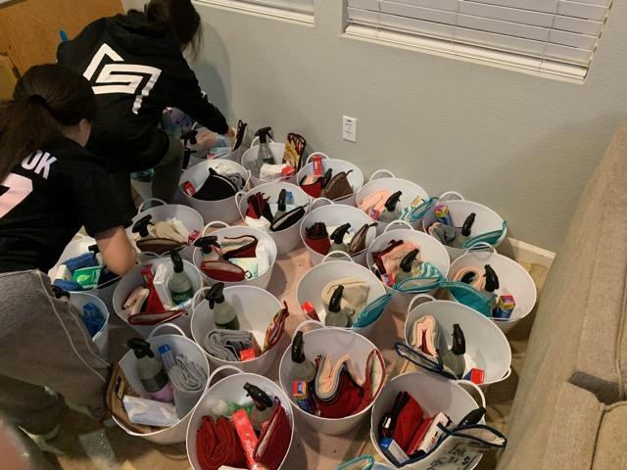

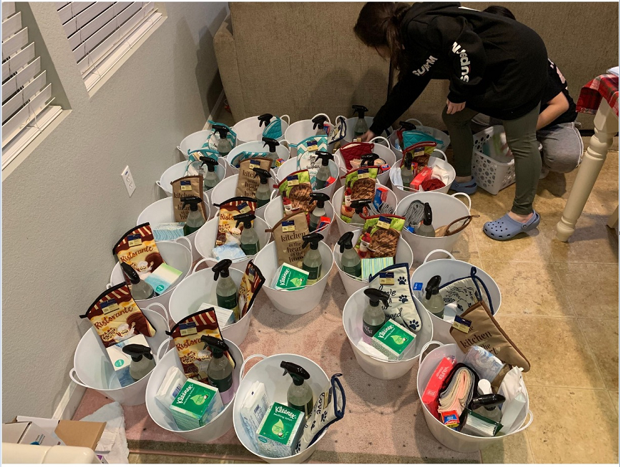

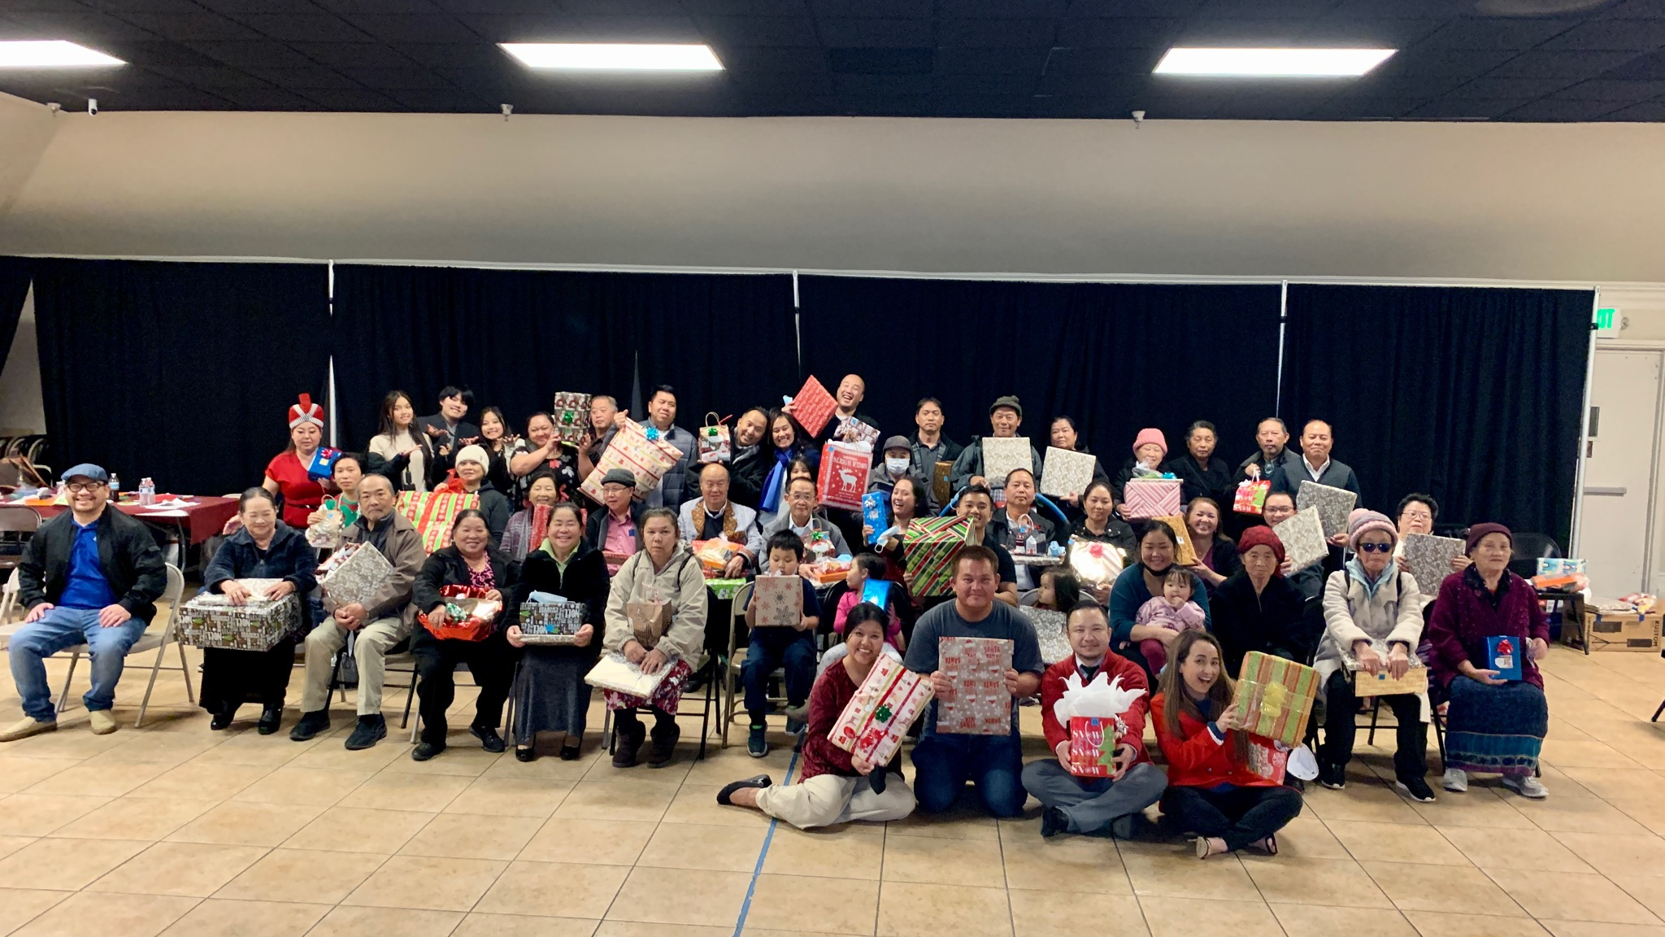
Christmas Dinner Pictures:

Children’s Ministry

Committee Members:
May Lee-Yang, Julie Xiong, Zoua Vang, Jennifer Heu, Ya Youa Xiong

Vision Of Ministry:
The purpose of ELC’s Children’s Ministry is to faithfully teach scripture and demonstrate the love of Christ to all children so that they will become disciples of Christ who trust, serve, worship, and obey Him now and into eternity.

Theme:
Encourage and empower children and their families to know Jesus and share His story. Support the development of a strong biblical foundation using The Heart of God curriculum.

Summary of Yearly Activities/Number of Attendees:
Children Events/Number of Attendees | Summary of Event
January 2021  Attendees: Varied | Zoom Sunday School (K-6) - ongoing  - Weekly lessons through Zoom  - Dig-in Curriculum
April 4, 2021  Attendees: Approximately 150-170 | Easter Event  - Message from Pastor Christopher  - Video/slide of children  - Zoom Sunday School (K-6)
April 29th  Attendees: Approximately 12-15 | Parent Meeting  - Covid Safety & sanitizing Procedures / Protocols  - Limited Sitting for each class  - Q&A
May 2, 2021  Attendees: Varied | In-Person Lessons Kickoff  - K-1: (13 seats available)  - 2-3: (9 seats available)  - 4-6: (11 seats available)
May 27, 2021  Attendees: Approximately 10 | Teacher Training / Orientation  - Dig-in Curriculum  - Covid Safety procedures  - Sanitation procedures  - Q&A
June 27, 2021  Attendees: | Promotion Ceremony  - 13 children promoted  - Bibles given as gift  - Cake provided
August 6-7, 2021  Attendees: Approximately 35-40 children not including volunteers | Vacation Bible Study (VBS)  - Theme: Anchored  - 2 day event  - Provided Breakfast, Lunch and Dinner  - Theme Messages given by May Lee-Yang  - Activities Stations: Led by adult volunteers  - Group Leads: led by youth
October 30th  Event Lead by GG’s | Fall Festival  - Devotion from Julie Yang  - Lead worship (Youth’s help) - VBS Songs
November 7th, 2021  Attendees: Approximately 40-50 (includes teachers, volunteers and family) | Teacher & Volunteer Appreciation Lunch  - Church Multipurpose Room  - Devotion/Encouragement from Pastor Christopher  - Catered Food  - Gift bags were provided for teachers
November 20, 2021  Attendees: Approximately 30-40 kids (not including volunteers  Event Lead by Hmong Ministry | Thanksgiving Banquet  - Lesson given by Sydney Vang  - Short Movie  - Arts & Craft  - Dinner: pizza, chips & water
December 19, 2021  Event Led by Men’s ministry | Christmas Combined Service  - Video / slide of Children Ministry  - Christmas Activity  - Dig-in Lesson

Overall areas of success:
- Lots of support from youth

Overall areas of needing improvement:
- Need advanced notice of CE support with events and programs (videos, slideshows, child care, etc)

Discipleship Annual Report

Committee Members:
Blong Thao & Lee Lo
Vision Of Ministry:
The purpose of this ministry is to bring believers and non-believers to a loving relationship with Jesus Christ through a study of a curriculum/book and through fellowship.
Theme:
N/A
Summary of Yearly Activities/Number of Attendees:

Events/Number of Attendees | Summary of Event
Date: Weekly (Feb-June)  Number of Attendees: 10 | Event Name: Church Plant small group  Summary of event: A book study of “Finding Organic Church” by Frank Viola; group study of “Church Planting Churches” podcast by TGC; and various special events
Date: Mondays  Number of Attendees: 8 (6 CLA students, P. Kongchingh, P. Blong) | Event Name: Young Adult CLA  Summary of event: Students discuss and learn about the life of Jesus according to the Gospel of Matthew (SEAN). The group preached to an audience that included the Governing Board, a small group, and peers. They also led a Night of Worship event (Nov. 13).  CLA graduates: John and Malya Yang, Ger and Jennifer Vang, Fred and Jessica Thao, and Se and Cho Kue.
Date: August/September  Number of Attendees: 10 | Event Name: Small Group Leader training  Summary of event: Persons interested in leading small groups gather for training on small group ministry. The group also discussed ideas for specific ministry groups and best practices.
Date: September - December  Number of Attendees:  Alee/Solaeta – 8 adults + children  Maria/Gance – 5  David/May – 15  FPU - 9 | Event Name: Small Group Ministries  Summary of event: There are 7 small groups at the moment. Six of these groups are life groups: Toby/Lee (family), Tony/May (family), Fred/Jessica (family), Alee/Soleata (married w/ children couples), Maria/Gance (women), and David/May (youth). The seventh group is Financial Peace University, facilitated by Blong.
Date: November - ongoing  Number of Attendees: 26 | Event Name: Mentorship Ministry  Summary of event: Individual couples meet with mentees and study “Abundant Life.”  Nik and Bao Moua completed study of “Abundant Life.”
Fellowship Ministry

2021 Committee Members:

Mai Yang | (916) 834-0395 | maeghan_06@yahoo.com
Jones Lee | (916) 494-2382 | leeyouan.jones6@gmail.com
Kayo Lao | (916) 812-6144 | kayolauj@gmail.com
Lue Thao | (916) 903-8888 | lue_thao@hotmail.com
Alex Lee | (916) 417-6384 | alytx10@gmail.com
Serena Xiong | (916) 837-1250 | serena.xiong28@gmail.com
Tony Yang | (916) 705-8656 | ezcape33@gmail.com
May Lee-Yang | (916) 501-4663 | leeyangm@yahoo.com
Cindy Xiong | (916) 799-5888 | say_xiong916@yahoo.com
Nou Vang | (916) 833-8575 | mrjmrsc7778@yahoo.com

Vision:
To offer an atmosphere where members and guests have an opportunity to fellowship and create meaningful relationships by providing snacks to fellowship with one another.

Operations:
Unless there is a special event, Fellowship takes place every Sunday. A lead and a floater are assigned each week to provide snacks after service.
- Lead Role – Purchase the snacks, prepare his/her items before or during service, set-up, clean-up and take down fellowship at the end of fellowship.
- Floater Role – The floater will assist the lead with his/her snack preparation, set-up, clean-up and take down.

On days when the youths are using the fellowship hall, please be mindful and set up the snack table elsewhere.

The church will provide the required utensils (ie, plates, forks, spoons, cups). If it is your week and notice we are running low on supplies, you may purchase the item(s). Please keep a copy of the receipt. You may also inform Mai or Jones in advance so that we could request the item(s) to be purchase.

Success:
Overall, all the events Fellowship participated in were a success.

Challenges:
Due to the pandemic, the fellow team was short staffed from 9 couples to 5 couples and were unable to have floaters assigned. In addition, team members were spending a little over $80 for snacks due to increase in ELC members (mostly youth and children) since in-service opened up.

Budget Proposal:
The current budget is $4,160 for the 2021 year. $80 maximum has been budgeted for snack purchases.

Summary of Yearly Activities involving Fellowship:

May 2021 – Mother’s Day
- This event took place on Sunday at ELC location.
- The fellowship team prepared Kapoon in celebration of Mother’s Day.
- About 250 bowls were prepared and handed out.

October 2021 – Pastor Appreciation (The Board – Soleata Xiong was in charge)
- The event took place on a Sunday at ELC Location and was a combined service.
- Fellowship assist with platting, making pepper, and handing out pack food to members and guests along with cleaning up after the event.
- About 260 plates were packed and handed out.

December 2021 - Christmas (Men’s Ministry – Ger Vang and Hang Xiong was in charge)
- The event took place on a Sunday at ELC location and was a combined service.
- Committee assist with platting and handing out pack food to members and guests along with cleaning up after the event.
- About 280 plates were packed and handed out.

Comments and Recommendations:
- Jones Lee and Mai Yang will continue being coordinators for 2022.
- Pending new coordinators to be appointed for 2023.
- It was recommended and approved to increase the snack maximum spending from $80 to $100 for the 2022 year.

Praise & Worship Ministry

Vision of Ministry: Continue to build up leaders
The Goal is to continue to create a process to build leaders. Individuals in which we will be able to equip them to lead the team and the congregation. Leaders will help aid in worshiping God by intimately knowing the structures of the worship songs. Leaders will also be able to instruct and correct musicians with confidence whether through singing or in musicianship.

Theme: Fellowship (continued from previous year)
• To build relationships and communion with one another in relatedness to how Jesus builds relation through the Father. • To share a common bond in the works and service of Worship.

Summary of yearly activities and number of average attendees:
• AV Appreciation Event
• Weekly practices/rehearsals average around 3-4 people on due to social distancing.
Overall Area(s) of Success:
• Improvements with over all communications with musicians/singers.
• Roles and responsibility of each worship members are being met.
• Created new procedures for worship to be streamline on both Facebook and Youtube.
• Also were able to arrange outdoor settings for outside service and worship.
• Incorporated the single adults to assist with worship on a monthly basis. To help build and grow the single adults to equip them for future leadership roles.
• Introduced new songs to the congregation’s repertoire.

Overall Area(s) Needing Improving:
• Find an evening out of the week for a time of fellowship.
• More scripture reading and devotion time with God to reflect on worship as a whole.
• Continuous improvements for more activities to continue to build relationship and communion with one another.
• Spending more quiet time before worship service for prayer and devotion.
• Create a Zoom environment so we can continue to meet virtually and safely.
6) Comments and Recommendations
• Will be needing additional inputs on what activities members would like to incorporate.
• Additional feed back and ideas to help with improvements on fellowship and communion.
• Devotional reading activities/materials that will help organize the team for consistent scriptural readings.
• Zoom activities so that groups can meet virtually without compensating fellowship time.
• Issues with having available musicians to be utilized in worship, mainly bassist guitarist, keyboardist and drummer.

.
Safety and Security Ministry

Committee Members:

English Service: Alee Xiong, Ger Vang, Xeng Her, Tua Vang, Yee Xiong, Bee Yang

Hmong Service: Donnie Her, Chou Lee, Neej Fwm Vue, Thomas Yang, Moua Lee, Va Chang Lee, Lue Thao, and Tom Nom Thoob Yang

IT/CCTV: Ger Vang

Mission and Vision of Ministry:
We are committed to provide safety and security services for all who worship at Eternal Life Church. The primary purpose of the Safety and Security Ministry at Eternal Life Church is to maintain a peaceful, safe environment which is conducive to teaching, learning, working, living, and sharing in the Word of God.

Summary of Yearly Activities:
Due to Covid-19, this year we were unable to gather in large groups for service until mid-April 2021. During that time the Safety and Security Ministry and its members monitored the Closed-Circuit Television (CCTV) remotely. As Covid-19 restrictions rescinded, the campus reopened for in-person service and the Team transitioned back to their regular duties.
When the campus reopened, the County Public Health Officer put an order in place, which restricted local authorities from citing the homeless taking shelter in cars, RVs and trailers parked on city streets. The order also restricted the removal of life necessities from the homeless including tents or other living structures, hygiene, food, water and medical supplies, as well as mobility devices. With homeless encampments being cleared and fewer restrictions homelessness has become more prevalent in the area our church campus is located. This provided opportunities for us to meet and witness to several homeless individuals. We offered them food, water and prayer. Unfortunately in some instances, we’ve had to ask individuals to leave the campus. Most were cooperative; however, a few were not, which required us to contact local authorities to assist due to safety and security concerns. We look forward to do more ministry with the homeless in our area and hoping to work with the Men’s Ministry to put together a hygiene fish kits for those in need.
The church campus is located in central South Sacramento where the crime rate is higher than normal. We’ve had a few friends from the local law enforcement agencies drop by from time to time to visit with us. This year there was shooting across the street from us, just northeast of our church building. The Team along with Information Technology Ministry Leader (IT) was ask to gather information to assist detectives in the investigation. We worked together and provided detectives with CCTV footage of the vehicle involved in the crime. The detective was very pleased and thankful for our help.
Aside from the above mentioned, we had the opportunity again to provide safety and security services for multiple ministries and event coordinators this year including the 10 Year Anniversary of the Church, Heavenly Harvest, Mission Conference, Night of Worship, Thanksgiving and Christmas.

Overall areas of success:
CCTV surveillance cameras have been a success. The cameras are our eyes and ears when we cannot be there in person and serves as a crime deterrent.

Overall areas of needing improvement:
Better communication between event coordinators and Safety and Security Team. We would like to be notified in advance of their need for our presence and assistance so that we can schedule team members and plan accordingly.

Recommendations:
We recommend Board members and anyone in a leadership role to get training in CPR/First Aid, Strategic/Critical Incident Planning, verbal de-escalation and physical intervention.
We also recommend more lighting in the parking lot area, new fencing and some barbwire work done on the northwest corner of the campus, as well as, landscaping around the campus so that the campus appears occupied and taken care of. This serves as a crime deterrent as well.
In addition, we are looking forward to working with the Men’s Ministry in purchasing and putting together hygiene fish kits for the homeless and those in need.
Moreover, we are in need of more hands and feet.
Lastly, we ask the pastors continue to pray God continues to give the Team grace to do a better job in the new year so that we can redeem the time and to do it well with the resources that we have been given so we can truly contribute all to God’s glory.

We praise God, for Pastor Daniel, he is the first line of defense and truly our gate keeper. We also praise God, that the entire team has termed out but has committed to another year of ministry. We are humbled and blessed to be able to serve the Lord.

Here are some photos to sum up 2021:

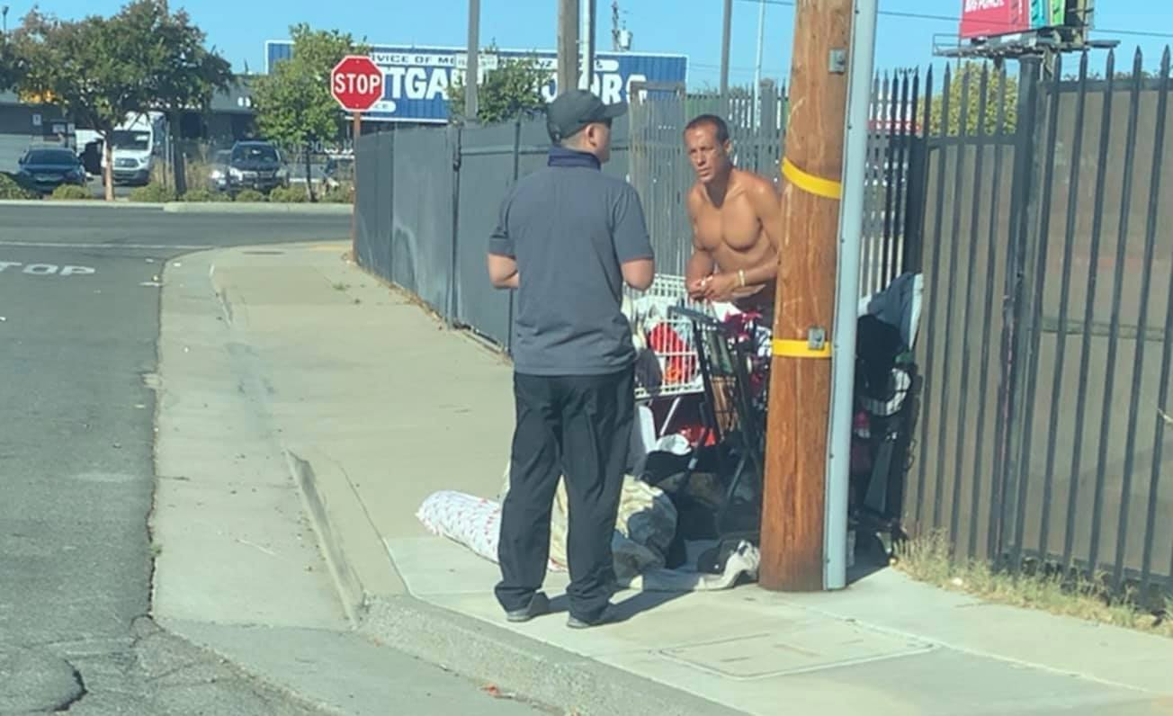
Placencia is a homeless man who camps just outside of our campus. He shared his story with us about how bad decisions led to him becoming homeless. While witnessing to him he confessed that he believes in Jesus.

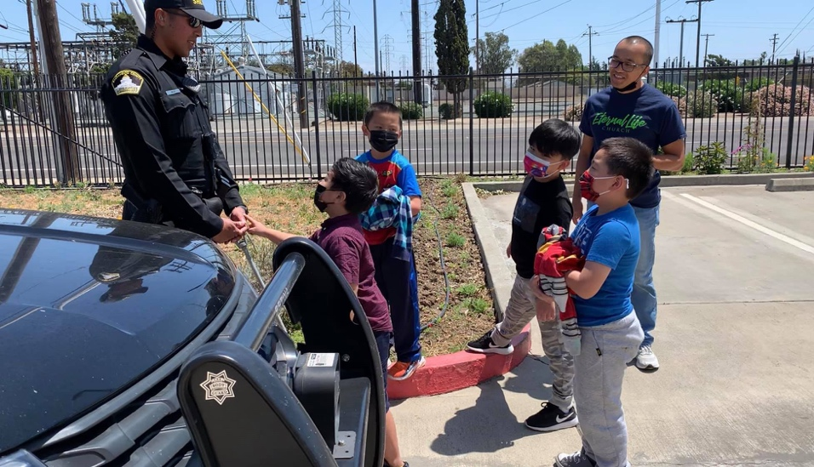
Deputy Meza, a friend and fellow believer, stopped by to say hello after Sunday service.

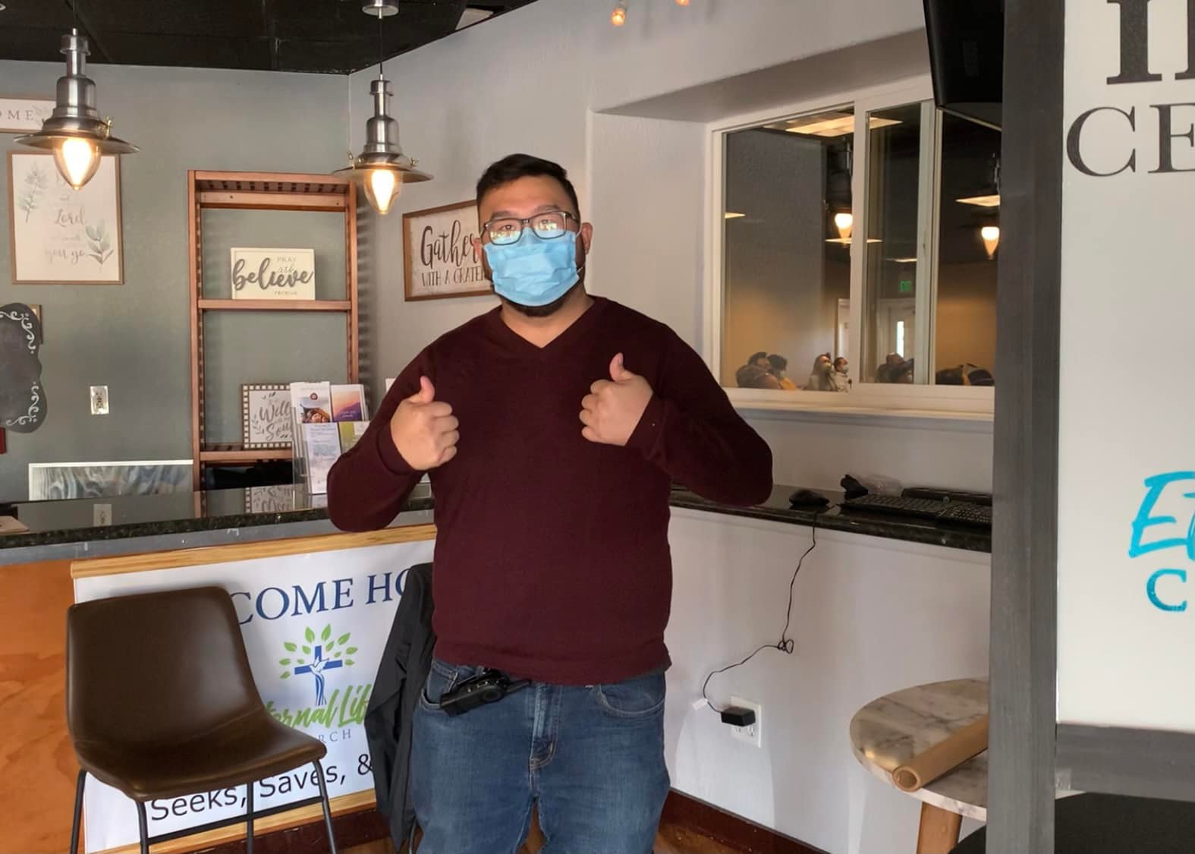
Brother Xeng Her, business as usual with a positive attitude, hanging out in the newly designed welcome center.

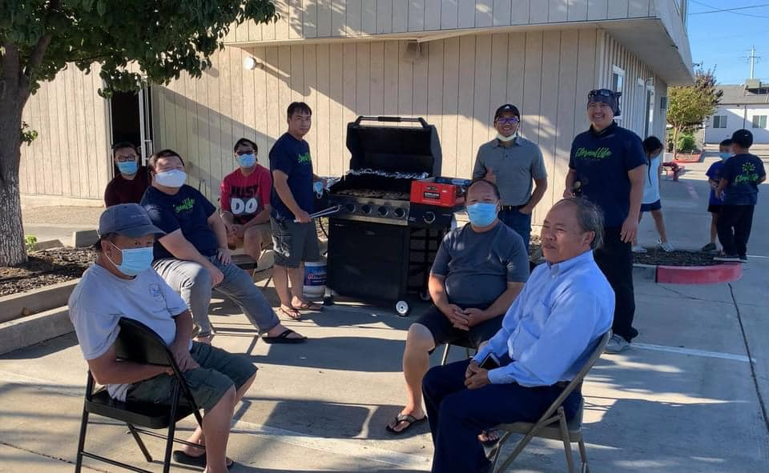
The Safety and Security Ministry Team barbequed, fellowshipped and enjoyed a short devotion on One Voice and One Mind (Romans 15: 5-7).

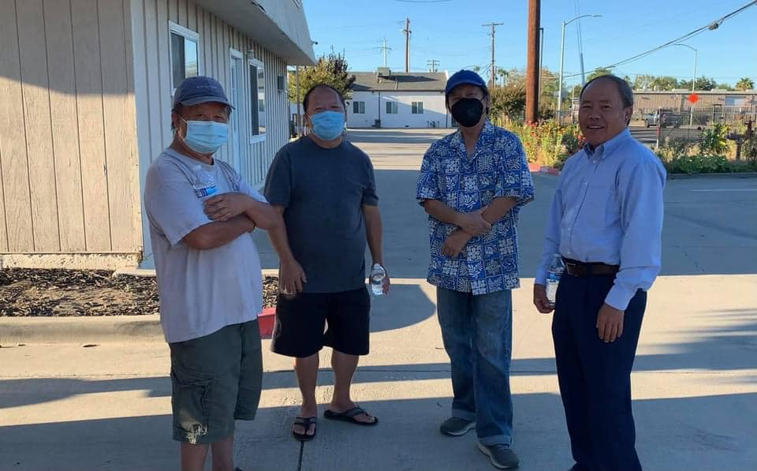
Brothers Neej Fwm Vue, Tom Nom Thoob Yang, Pastor Daniel Yang and Thomas Yang enjoying each other’s company.

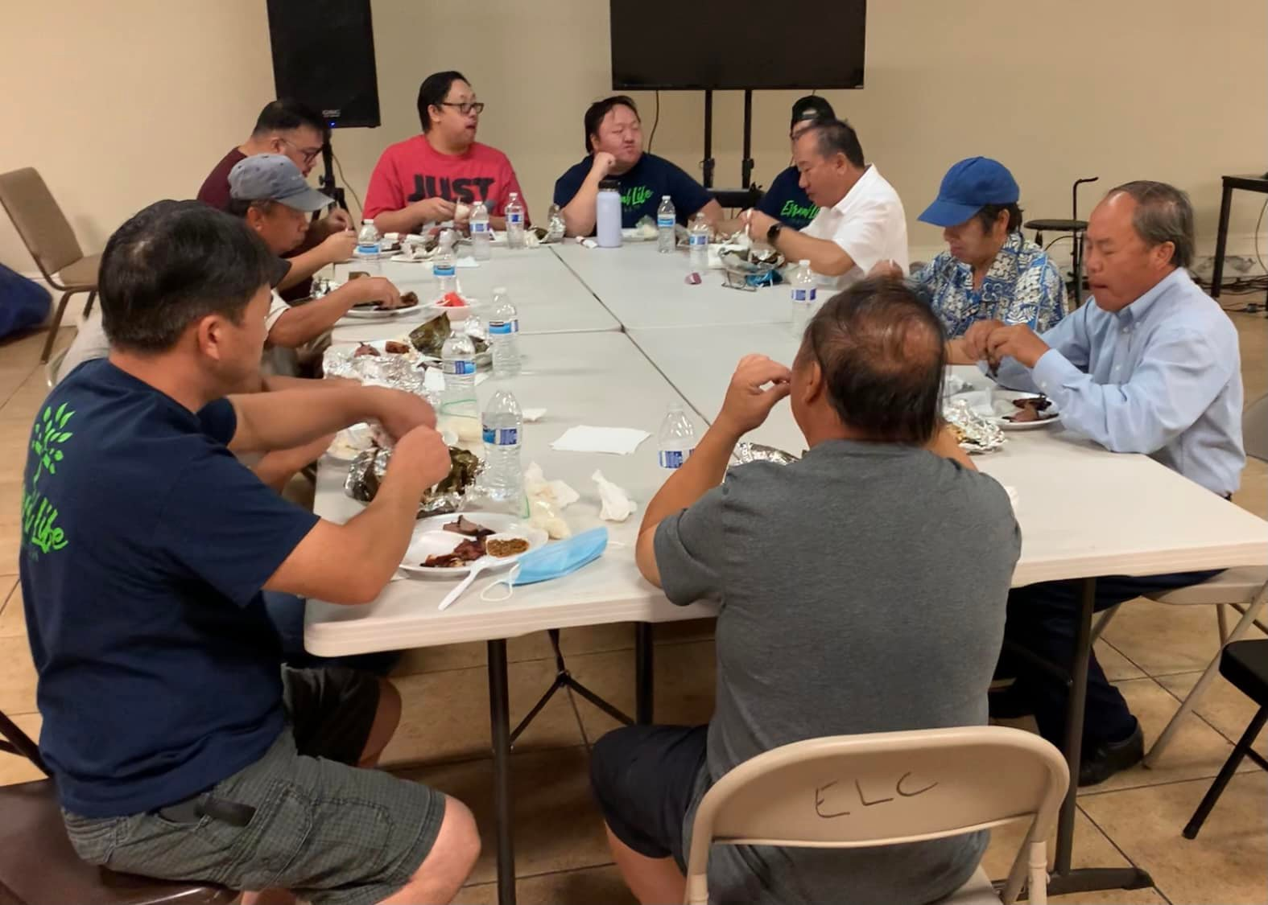
The Safety and Security Ministry Team and family along with Pastor Daniel Yang and Pastor Christopher Thao enjoying a meal together.
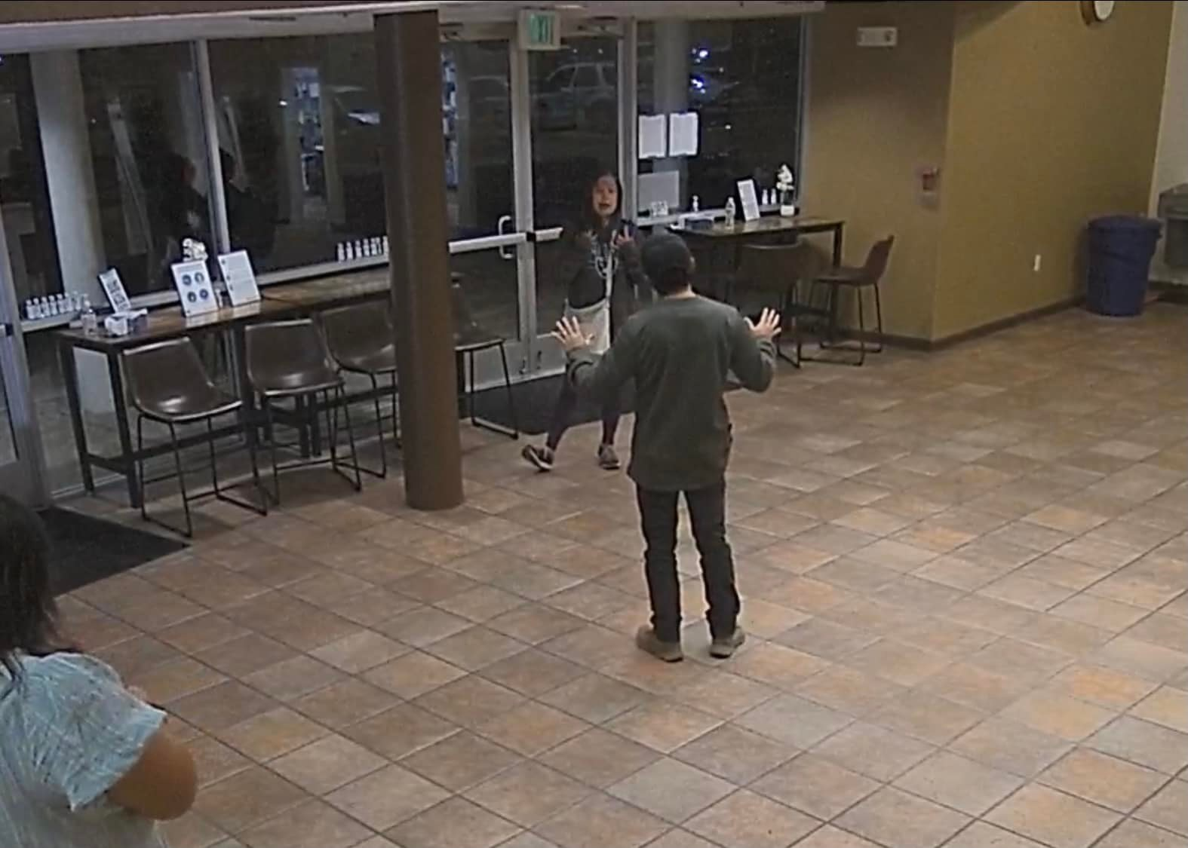
Brother Ger Vang attempting to de-escalate a situation with an uncooperative visitor during Night of Worship.

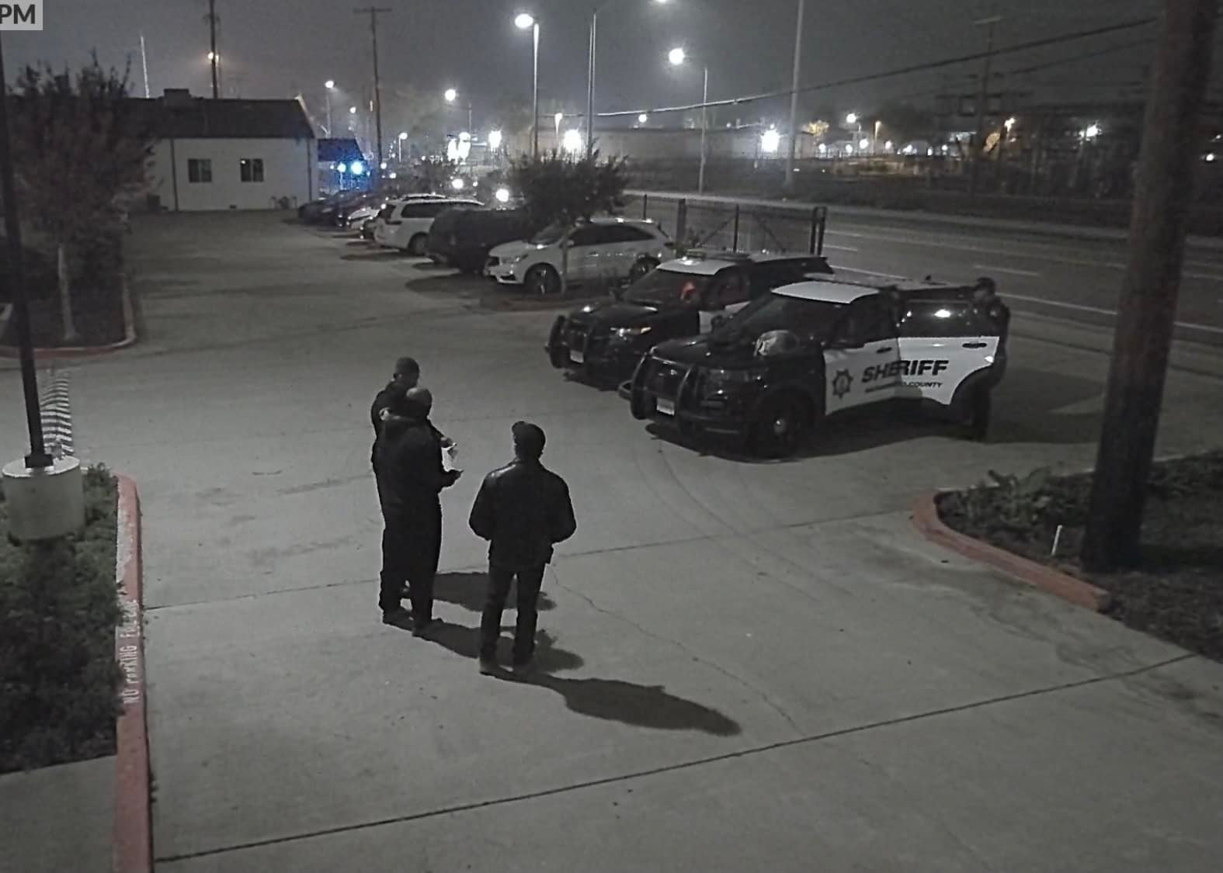
Deputies responded to assist the Team with the uncooperative individual during Night of Worship.
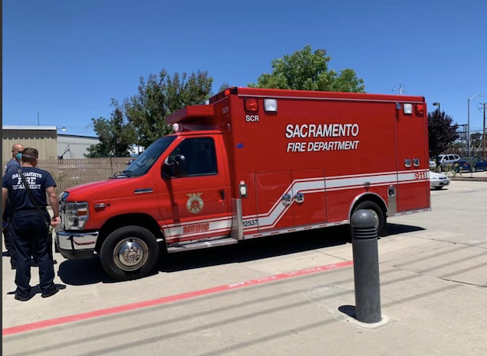
Sacramento Fire Department on campus to respond to a medical emergency.

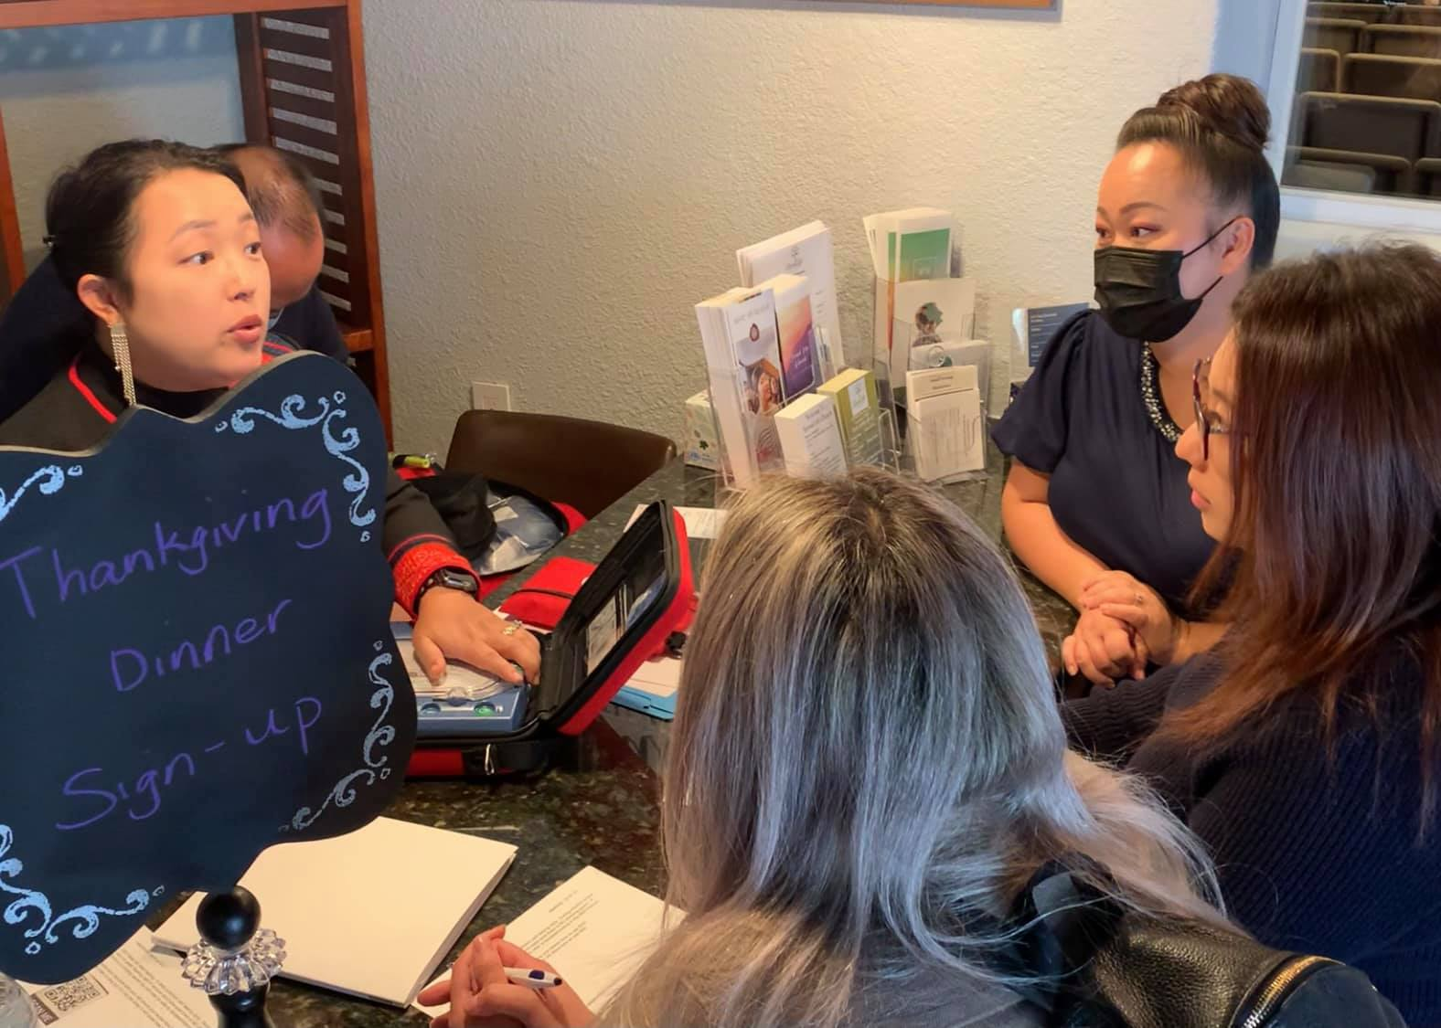
Some of the nurse sisters going over how to use the new Automated External Defibrillator (AED) machine.
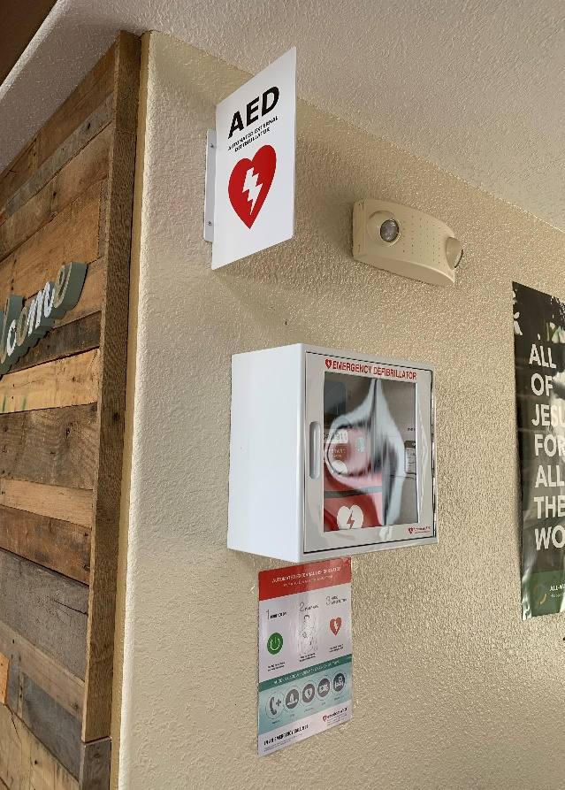
The new AED installed and ready for use.

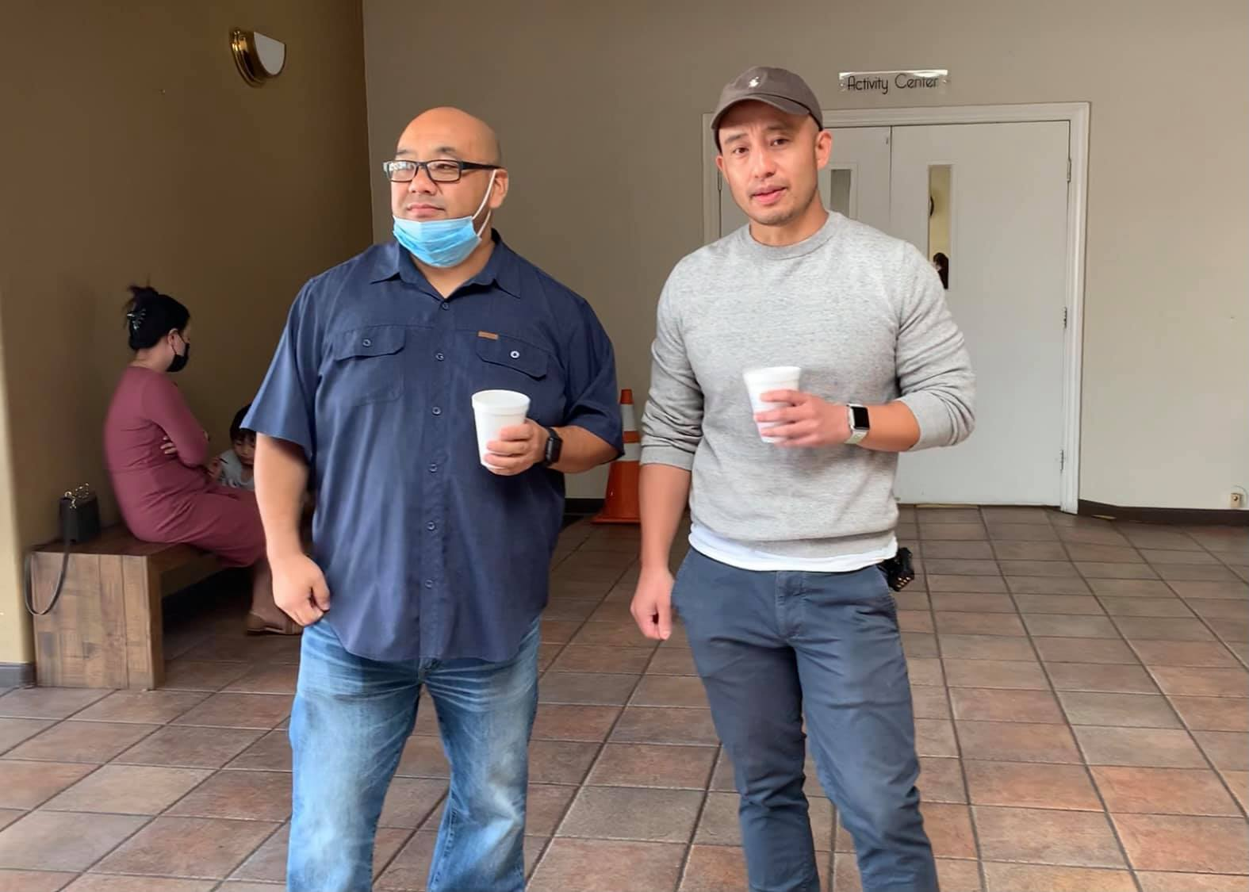

Brothers Louie Thao and Jones Lee from the Fellowship Ministry assisting security during Sunday service.

Usher Report
Our Ministry
Coordinator: Alex Vang
Lead: Chwseng Thao, Moses Thao, Vincent Yah, Tony Moua
Ushers: Chew Saevang, Kennedy Xiong, Kyle Ly, Xeng Yang
2021 Activity
Our principal activity as usual is the collection and recording of the offerings, tithings, great commission, fundraising, etc. We greet people and also offering to assist people in seating on regular service or special event.
This year we participated in the Thanksgiving event, in support of the Security Team and Hmong Ministry.
Here is what I think about Special Event at Church: It is important that all Ministries are informed on how the event will takes place. And how each Ministries will be involved. I deplore the lack of communication. So, it is important that before each event, we have to communicate briefly and clearly.
This concludes my report for 2021.

Alex Vang
Ushers Coordinator

The Lighthouse Church Plant

Introduction
Before Jesus ascended to Heaven, he left one simple command for his followers, “All authority in heaven and on earth has been given to me. Go therefore and make disciples of all nations, baptizing them in the name of the Father and of the Son and of the Holy Spirit, teaching them to observe all that I have commanded you. And behold, I am with you always, to the end of the age” (Mat 29:18-20). In the spirit and power of Christ’s command, the church plant’s vision is to “Go and make disciples of all nations, baptizing them, and teaching them in the name of Christ.”
Since February 2021, a small group of 5-6 families have met regularly to learn more about church planting. It is my hope that out of these interested families, some will come to recognize their calling as church planting partners and be committed to the rigors of “GOING” to the unchurched and spiritually dark places of Sacramento and Elk Grove for the sake of the Gospel.
2021 In Review
Here are some of our highlights from 2021:
- We met for 12 weeks to read, study, and discuss the book, “Finding Organic Church” by Frank Viola.
- We met for 10 weeks to listen to and discuss a church planting podcast series by The Acts 29 Podcast.
- At each session we dedicated significant time for prayer and doing bible study from the Book of Acts.
- The small group took a weekend retreat to Zephyr Point - Lake Tahoe, to fellowship, learn, and reflect on God’s calling for the church plant.
- For our evangelism event, the church plant small group rented a movie theater and invited our unchurched friends and family to watch the movie “Christmas with The Chosen: The Messengers”.
- Jerry and Pa Ia underwent their church planter assessment with CPD. They passed but with a few minor conditions that still needs to be met in upcoming year.
- The church planting small group and CPD officially recognizes this church planting group as… “The Lighthouse”.

We Need Your Support
As The Lighthouse church planting team continues to grow in our knowledge of church planting and go through the process of becoming an official church plant with CPD, we ask that you support us by praying with us for these specific things:
- For clarity of vision and mission for the church plant.
- For us to be brave, courageous, and bold in sharing the gospel to the unchurched and unsaved.
- For us to reach the people and areas of Sacramento and Elk Grove that God has already called and prepared for the harvest.
- For Jerry and Pa Ia to complete their church planting conditions.
- And for Jerry to complete his accreditation with the CMA to be a licensed worker.
In Closing
It has been a tough 3 years since social unrest and the COVID-19 pandemic has ravaged the world as we know it. But we do not fret because it is in these dark times that we see most clearly the light of God’s love, grace, and mercy. It is also during these dark times that we must stand in glorious contrast to the surrounding darkness as living testaments of the light which we have in Christ and become the “Hope of Glory” as mentioned by Paul in Col. 1:27. We are so proud and honored that Eternal Life Church is sending us out to multiply that light of hope. We thank you for your partnership with The Lighthouse church planting team… Together let us display to Sacramento, Elk Grove, and the world… the Glory of Christ.
Your Brother in Christ,
Jerry Lao

Auditor’s Report
